HTML 5

Let's talk about what we'll cover in this course.

In Week One the focus is on questions.

It's not on coding, it's on questions.

I want you to understand what happens when you type something into the URL.

If you type in www.introwebdesign.com,

how is this page magically appearing in front of your browser?

I also want to talk to you about what types of tools you are going to need

in order to code.

We're gonna talk about editors and browsers and

other different software tools because I want you to know right from the start

what you're going to need in order to succeed in this class.

Finally, we're really going to talk about HTML5.

What happened to HTML1?

What happened to HTML2?

What is this evolution of what's going on with web design and the languages we use?

In Week One, again, almost no coding.

Really, just giving you an idea of how the web works and

why it's important for you to be able to interact with people and

with code that's being used to create your sites.

Week Two, we're gonna talk a little bit of theory, and then, unfortunately for

some people, a lot of code.

There's this idea of something called the Document Object Model,

upon which all webpages are built.

If I can get you to understand just a little bit about that, then later on,

if you decide to go off and use WordPress or some other software to make your own

website, you're gonna be able to really understand what's going on so much better.

We're gonna talk about things called contextual tags and headings and

different things we can use to make our site have different meanings and

different appearances.

We're going to talk about links, images, lists, tables,

and also multimedia in case you would like to add any video or audio to your site.

Week Three, we're really going to put it all together.

At this point, you should know just enough about HTML5 where you'll be dangerous.

Where you can create something that works but doesn't work all the time.

In Week Three, we're gonna put it together, and I'm gonna talk to you about

some of the things that are often overlooked, such as validating your code.

How can we make sure that the code that you wrote doesn't just look good,

it's syntactically correct?

It's going to work everywhere.

Again, when we validate your code, we'll talk about the syntax but

we'll also talk about accessibility, which is hey,

we validated your code to make sure the rules are there.

Let's also validate and make sure that the meaning is there, as well.

Finally, we'll talk about what's called domain name registration and

web hosting because it's a lot more fun to make websites if you can actually put it

out there on the internet and let your friends and family see it, as well.

Finally, we'll work on a final project where you'll put together a lot of

different things that you've been learning.

You are going to create what we call, syntactically valid multipage website.

Your site will have at least two to three pages.

After you've done your coding, you'll run it through to make sure it validates and

it's very accessible.

Your final project is actually going to be something that's a little bit ugly,

I'm gonna admit to right now because we're not going to be talking about styling,

we're not talking about different things.

I really just want you to understand the HTML5 language and

that's all about content.

Let's talk logistics.

Let's talk about who this class is for.

Who am I aiming for for my star student?

I'm really looking forward to teaching the complete beginner.

This class is not for those people who were building a computer down in their

basement when they were 12 years old.

You are very welcome to hang out with us but

we are really here to talk about how we, through persistence, can create a website.

One of the things that I'm kind of anti about is the word passion.

Now, I'm passionate about teaching you this material but

I don't really feel like you need to be passionate about technology or

passionate about computing to really get a lot out of this class.

Instead, it's about persistence.

I'd like you to just hang in there and learn enough that you can go off and

really help people build better technology.

A little bit about of who I am, I have a PhD in computer science which is

really the least important part of my qualifications to teach this class.

Instead, I have two decades of teaching experience and

I've taught a wide range of different students.

My emphasis is always been on education and I'm somewhat famous for

running around the classroom helping people debug their code,

finding out what's going on here, finding out what's going on there.

This whole idea of teaching this class is

novel to me because I am sitting here not moving.

The important part is that I really do care about people succeeding and so

I am hoping that I can help you take your skills to the next level.

Here is that what everyone wants to know.

In this class, what kind of workload will there be and how will you be evaluated?

There are going to be weekly videos.

Some of them are like this, a lecture format.

You should really feel free to watch them anywhere but

I also like to include some videos that are going to be much more demo format.

By that, I mean you really want to watch the video with a computer next to you, so

you can type along and test it out and try it.

There will be weekly readings.

Most of them will be from a free online textbook but

there may be some other online articles I include as well, if I

happen to come across something that's very timely for what we've been learning.

There will be weekly assessments, typically, in the form of quizzes.

There will be that final project and I put in here warning, it will be ugly.

I don't mean that the process will be ugly.

I think you'll find it very straightforward.

It's just again, I can't emphasize enough that

this class is about the language HTML5, it's not about creating beautiful sites.

It's about you really learning just the building blocks and it's always so

much easier to build something ugly the first time than build something beautiful.

How will you succeed in this class?

In a perfect world, you would be coding with two or three other people and

you'd be talking and you'll never be coding alone.

I'm hoping that you'll create a community, probably through the message boards.

I need you to work smart.

One of the things that kills me is when people say I spent three or

four hours working on this.

I never want to hear that from a student.

Instead, I feel that if you've ever run into a problem when you're coding,

you should stop after 10, 15, 20 minutes max and go walk away.

Go get help from someone, take a break, think about something else.

It's all about working smart, not necessarily hard.

Next, you really need to learn to look things up on your own.

There is no way I can teach you everything you need to know about HTML5,

and you wouldn't want me to, it would be very boring.

Instead, you need to feel the confidence to go out and

use search engines to look up the topics that you're interested in.

My job is to give you those key words and key ideas so

you know what it is you want to search for.

Finally, you really need to practice, practice, practice.

You will not succeed in this course unless you've written the code yourself and

really tried to muster your way through some of the mistakes and

typos that you're going to have.

Let's just review.

Once again, this class is for beginners, and I'm excited to have you join us.

When you're done with this class, you will have the ability to write and

understand HTML5 code.

You're not leaving as a developer but

you are going to leave as someone who understands code.

Finally, one of the key things that I'm gonna stress throughout this whole course,

is that you will understand the importance of accessibility in technology.

If when this course was done, I had even one student who said, hey you know what,

I'm gonna go on and I might not be a coder but I am gonna go work with somebody else

to help make their code more accessible, I would be thrilled with that.

Welcome to the course and

I hope you have a lot of fun as you learn more about HTML5.

TEXTBOOK:

It is really difficult to find a textbook that focuses on just the basics. In the past I used a textbook that covered too many "extras". The new version of this course (and the entire specialization) will be using an online resource from Shay Howe. The link is [https://learn.shayhowe.com/html-css/.](https://learn.shayhowe.com/html-css/) You can also purchase a paper copy of the book if you prefer, but everything you need is free and online.

This book isn't perfect - it covers more than I would like to cover but it is a really good start. I do my best to direct you to sections that most closely follow what I will be covering in each video lecture.

While you are reading, make sure to look closely for code. This site uses CodePen - a tool that lets you see the code and the output. Clicking on the code will also take you to the CodePen site where you can try changing the code to see what happen.

**SOFTWARE**:

The **preferred** way to code in this class is editor software (Notepad, TextWrangler, Sublime, etc). Recently I have been using Visual Studio Code and I really like it. The software is free and works on most types of computers.

If you do not have the ability to access or install this type of software, there is an online editor at: <http://www.w3schools.com/html/tryit.asp?filename=tryhtml_intro>

# **Optional Resources**

I originally placed these optional resources at the end of Week Two. But students like them so much I am putting them here at the beginning instead. The textbook I link to throughout the course has nice, short chapters that go well with nice short lectures. These other (free) online resources are just as good if not maybe even a little better in some cases. So feel free to read them now or at the end of the class to help reinforce what you learn over the next few weeks.

W3Schools - Optional

Many people do not like the W3Schools approach to teaching web concepts. However, many students really appreciate the ability to manipulate existing HTML code and see (immediately) what it does. So if you would like the ability to write and test snippets of code, this is a good resource. Don't forget that you still need to validate your code.

<http://www.w3schools.com/html/default.asp>

### **Codecademy - Optional and more of a long-term prospect**

If you are looking for even more hands-on practice many people use the [Codecademy](https://www.codecademy.com/) website. This site awards badges as you complete skills. This site is free, but **registration is required**. My advice is to make sure you are doing more than just trying to "get through," and focusing on the concepts that you are practicing.

Today we're going to be talking about HTML5.

Specifically what it is, and why we aren't learning HTML1 instead.

So what is HTML?

HTML stands for hypertext markup language.

Markup languages are actually very common.

They're not the same as programing languages,

instead they're special languages that use tags to annotate or markup documents.

In HTML, the tags tell the browsers where you want to put headings,

images, lists, links, et cetera.

A .HTML file is a special kind of file.

You've already seen special file extensions before.

Whenever you open a file that has a .doc,

your computer knows to open it in Microsoft Word.

If you see a file with .ppt your computer knows,

oh that's a Power Point file, I should open it in Power Point.

In the same way, when you computer sees the .html file, it knows that it should

open it in an internet browser such as Chrome, Firefox or Safari.

Your browser can read this file and it knows how to display it on the screen.

It's more than that, HTML file tags also allow screen readers and other assisted

devices to utilize the tags to present the information in new and special ways.

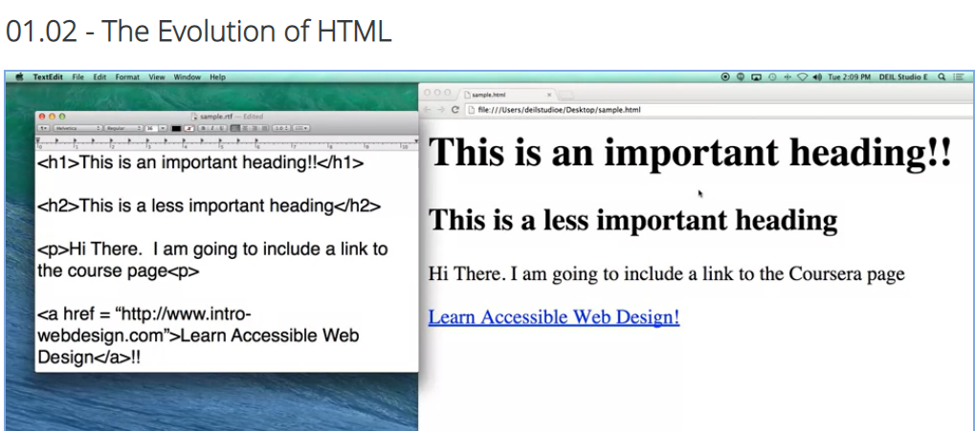

So HTML is very similar to English,

you can understand it even if you don't know much about it.

Let's look at this example HTML file over here.

Most of it is just a typical English language.

This is an important heading or hi there.

I am going to include a link to the course page.

But if you look closely, you can see we've added these little tiny tags

that the browser use this to know how to represent the material.

So, h1 is just the heading tag.

It says to the browser, hey this is something really important.

I want you to put it in bigger font, and also if someone is using an assisted

device, I want them to know if this is something important.

H2 also displays some sort of importance, but not as much.

I have a p tag for a paragraph,

and I have another tag down here called and anchor tag.

To let the browser know, I don't want you to just show this material,

I want you to actually link it to a different web page.

So here's the output when any browser would look at our code.

In the beginning, learning HTML is mostly about learning all those different

tags that I showed you in that file.

This is called learning the syntax.

It's how you learn which brackets to use, backslashes, and

different things like that.

You spend most of your time going, oh, did I remember that tag and

did I write it the right way?

That's very short-lived.

In just a little amount of time,

you're gonna gain the confidence to not worry about your syntax and

instead to be thinking about the semantics or the meaning behind the tags.

How important is this information that I'm trying to get across, and

is this the right tag to be using?

If someone's searching my page, can they find what they're looking for?

Even if they can't see the text, can they use the tags to navigate through it?

So what happened to HTML1?

Why are we using something called HTML5?

Well, let's talk about the early years.

HTML was created in 1990 as a way to electronically connect

different documents via hyperlinks.

Hence, this idea of a web of connections.

What was happening,

is that scientists were using the Internet to list their different research papers,

and you would have a long list, each paper independent of the other.

But, HTML, gave you ways that you could read a paper, and

right within the text, link to another exciting physics paper.

Because the audience from HTML tended to be people like my dad up there in

the corner, they were nuclear physicists, they didn't care about things such as

color, images, or anything that wasn't science related, and that was the key.

HTML was intended to work across any platform.

And in order to do this you really had to avoid things such as special fonts or

different colors or anything that was more about layout than content.

However, in 1993 Mosaic emerged as the first graphical browser.

And what that means is that there was a first browser to actually introduce

the idea of images and when that happened, there was a lot of

debate among the research community as to whether or not this was a good thing.

The pioneers really wanted to keep it simple content based,

let everyone access it.

But the innovators were saying no.

People like pictures, they like layout.

They like that even as much as they like the content.

So there is a big battle between how the Internet should evolve from that point.

So after Mosaic emerged, the use of the Internet just absolutely exploded, and

more and more people were using it for commercial means, instead of just for

doing research.

Mosaic had challengers though, in the form of Netscape, Internet Explorer and

other browsers.

This was the start of what we call the browser wars.

Each of these browsers decided that they wanted to create these proprietary tags,

tags that would only work on their browser.

Some of the examples were marquee, where you could have scrolling text, or

blink which would only work on some of the browsers and not others.

Other tags were proprietary, they actually worked on any browser, but

they went against the original spirit of HTML.

They were tags such as font or center, for centering your text or background color.

This may not sound like a bad thing, but

some computers didn't have the access, didn't have the ability

to have all the different colors that other computers might have.

And this led to some really ugly looking pages.

That also led to the origination of what we call the best viewed on messages.

When you went to a site you almost immediately told

which browser you should really view the site on.

Otherwise, you weren't going to get the optimal experience.

We all in a way suffer from browser wars, or best viewed on images today.

Many times when you go to a page,

you'll see that you can't actually access the full content if you're on your phone,

unless you click on a link to the full website.

So how did this happen?

How did we get to the point where different browsers weren't agreeing

on the different roles that HTML should play?

This comes back to the idea that no one runs the Internet or the Web.

However, some groups have taken a more proactive role

to try to help standardize what's going on out there.

The first is the Internet Engineering Task Force,

they really focus on the idea of how the different networks should collaborate and

how they should work together.

The World Wide Web Consortium, instead deals with HTML and the evolution of HTML,

they want to know what kinds of tags the browsers should and should not support.

Finally, one of the newest groups, The Web Accessibility Initiative,

they want to make sure, that no matter how people are accessing the web,

they have the same ability to view the content.

We had this evolution of browsers that we've been talking about.

In 1990 to '94 it was all very simple, text-based.

In '93, we talked about how the images entered the scene, and

pretty much exploded the Internet.

Cross-browser compatibility made many of the web pages just fall apart and

led to incredibly ugly code.

In the beginning of 2000 browsers went back to this idea of separating content

from style.

And in 2005 it became standard practice to use HTML files, which we are learning

about in this course, to create the content and CSS files to style it.

So as the browsers evolved so did HTML.

The way it tends to work in most computer signs and

technology fields is that it's the coders and the developers who push the standards.

So as coders learned that there more and

more things that they wanted the ability to do, it's the browsers job to keep up.

So, where are we now?

HTML5 is a cooperation between W3C and

the Web Hypertext Application Technology Working Group, and

what they've done is they've established these four guidelines for

how HTML5 should be approached as browsers go to support it.

The first idea is that new features should be based on HTML,

CSS which is the sign language, the DOM and JavaScript.

Nothing more.

They want to reduce the need for external plug-ins, it's very frustrating when

you're on a browser and you find that you can't watch the video that someone posted.

They also want to move so that mark up, or

the mark up language can replace scripting.

If you find that more and more developers are writing code to make something happen,

get rid of the code and just make a simple tag that can do it instead.

And finally, HTML5 should be device independent.

It shouldn't matter whether you're on your phone, you laptop, a PC or

even on a screen reader.

You want everyone the same access to the information.

So when you think back over this video,

there are certain lessons I really hope to stick with you.

The first is the idea that HTML is not a programing language, but

rather a way that browsers can translate documents into viewable webpages.

HTML was intended to facilitate many different content types.

Images, pictures, links, lists.

Every thing along that line.

What we've found thought the history of the Internet,

is that when designers want to do something They tend to write

nonstandard code to force browsers to do it.

So, this is why we're developing new standards in HTML5 to handle these new

requirements that people desire and push browsers to adopt the new standards.

Today, let's talk about the request-response cycle or

basically what happens when you type something into the address bar of your browser.

One of the things I think is really funny and I'm guilty of it as well,

is that we all do things and we have no idea how they work.

So, if I were to ask you when you type in an address, what happens?

So, this lecture is actually one of the most technical of this entire class.

I don't want to feel like you need to memorize this or write it down,

but I do think it will help you understand a little bit

more what's going on as you learn HTML5.

So, one of the things you might want to understand is the client-server relationship.

Servers are basically machines that hold all the resources.

Our hope is that they're always connected to the network.

Clients are what we're using,

where the machines that you use for personal use;

like laptops, phones, et cetera.

Let me show you in this picture.

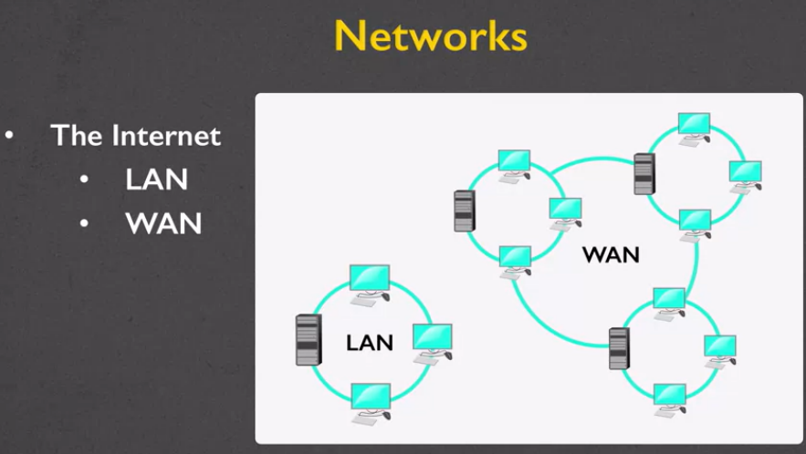

It's really common to use networks such as something called a LAN or a WAN.

A LAN is a local area network,

and so what I have right here is this idea that we can have

three different computers and they're all sharing one server.

Why would we want to do that?

Well, a lot of times,

you only have one printer or one of the different resources.

This way, all three machines can work together and share that one resource.

So, the LAN is the local area network.

Sometimes, you want to have something larger or a wide area network.

So, in movies, where the good guy is breaking into the building to steal the software,

what's typically happened is they have this server that

everyone who works in the building can access but no one outside the building,

or you can even have it across different buildings but you don't

want anyone from the outside to really be able to get your information.

So, local area network is like your office building.

A wide area network might be a university,

where you want to be able to share servers across multiple buildings.

The largest wide area network is, of course, the Internet.

So, now we get back to that question of

what happens when you type something into the URL?

What you're doing is that you the client are requesting

a web page and the server needs to respond with the appropriate files.

So, when you type something in,

this is called the URL.

Every URL has three parts.

The protocol, how you want to connect, the domain,

which is the server,

and then optionally, you can include the document.

So, even though you're typing in one URL,

one of the things to realize is that usually,

you're actually requesting lots and lots of files all at once.

So, the protocols that most people have seen;

the first one is HTTP,

the Hypertext Transfer Protocol.

The second one, HTTPS,

is the same idea,

only now we're having a more secure protocol.

So, if you're ever connecting to a bank or any place where you're putting in passwords,

make sure that the first thing you see in that URL is HTTPS.

If you don't, don't connect.

The third one is called the File Transfer Protocol.

It's a little bit different.

When you see HTTP,

it's expecting that you're going to give back and forth HTML5 code;

with FTP, it could be any type of file.

So, we have the protocol,

now let's talk about what the domain names represent.

Usually, the domain names are something recognizable, such as umich.edu,

would be for University of Michigan.

Google.com, wikipedia.org.

So, each of these sites has a different top-level domain.

How did you get them?

How do some people get to be.edu and some.com, some.biz, et cetera?

Well, they're actually determined by ICANN.

Their job is to go in and decide which types of

organizations qualify for different domains.

I've included a link here if you want,

you can go and see what the different types are.

But the important thing to know is that

your domain name is actually mapped to an address.

In the old days, like when my Dad was on the Internet,

if he want to connect to some place,

he would actually type in numbers;

185.261 et cetera, et cetera.

Well, there's been a new version of IP addresses,

because every single client needs their own address.

If you think of how many people have laptops and smartphones,

we need a lot of different options.

So, with these IP addresses,

you basically have sets of numbers,

you have these different sets right here,

where each X can represent one of 16 different values.

So, you can see we have a lot of options,

over 300 trillion, in fact.

As I said, luckily for you,

the domain name server lets you type in something really simple like Umich or Google,

and it's the one that turns it into that really long number.

The last part of your URL is the document.

So, sometimes you want to specify a very specific document that you want to get.

So, for instance, the contact page,

or in this case,

another one I have the file that's inside a folder.

But sometimes you don't put a document at all.

In fact, most of the time, you don't.

If you type in wikipedia.org or Facebook.com,

there's no filename. But that's okay.

Every server has a default document that it's going to return.

Usually, it's called index.HTML.

All right. So, we figured it out.

We know what it means when we're typing something in.

We understand the request.

What happens though once we type that in,

is we are actually going to get back a lot of information.

Headers, cookies, form data,

all the stuff that you don't see.

So, the important thing to know is that the server returns files, not web pages.

For a lot of us, we are very visual.

So, when we type in a URL,

we're looking and we're like,

"Oh, here's my page."

But sometimes the browser might be returning

something for different types of screen readers,

assistive technology, so it's not returning a web page,

it's returning lots and lots of files.

Hopefully, I will admit that sometimes the server can't fulfill the request.

If it can't, it'll send back an error code.

I think a lot of you are familiar with 404,

where it says, "File not found."

That usually means you typed something in wrong.

If you get a 500 error,

that actually means that the servers down.

So, you may as well go have a snack,

do something fun, come back later and type it in again.

So, I want to do a live demo with you of what happens when we type something in.

So, I've written it down for you.

It looks up the domain,

the DNS returns an IP address,

and then a whole bunch of files start to be returned. Let's take a look.

What I've done here is I've gone to the school of

information site at the University of Michigan.

I simply typed in si.umich.edu.

I didn't type in the protocol because it usually just defaults.

So, what you see here visually is a page.

Student looking out, looking very inspired, et cetera.

But now, I'm going to do a little trick here,

where I right-click on the screen,

and I'm going to choose the option that says, "Inspect."

A window's going to pop up to the side here.

I'm going to say, "You know what?

I would like to see all the information that's

being returned when I actually request this page."

I'm requesting one page, I'm going to hit "Refresh."

If you look off to the side,

don't worry that you can't see the details.

But you should see that the single page is actually made up of lots and lots of files,

and each one of these files was a separate request.

Okay. So, let's review.

This was a long video,

where really all I want you to come away from it with is

the knowledge that every URL has those three parts;

the protocol, the domain, and the document.

Realize that what you're creating is bigger than just one file at a time.

Every request-response cycle is usually lots and

lots of rounds of communication between the client and the server.

So, we're going to start off small.

We're going to do one file at a time,

but you can always look ahead to building bigger and bigger web applications.

One of the things that you might notice is that there are a lot of different options

for how you can view web pages, and

these different options are called your different browsers.

So different browsers have their pros and cons.

I am not one of those people who get really passionate

about having using one over the other.

But I will tell you, as you become a web developer,

if you decide to, you're going to want to know some of these differences.

It's perfectly natural to have a preferred browser, for

most people it's whichever one was installed on their computer.

But, when you want to create websites, you might have one browser you use to

look at things, but you really want to test your site on multiple browsers.

So let's talk about some of the differences.

First, we have internet explorer and for a long time, it was the most popular

browser and that was just because it was the one that came with Microsoft Windows.

It was platform-dependent and

what that means is that it doesn't automatically work if you have a Mac.

In 2015 Windows 10 came out and instead of including Internet Explorer as a default,

it's using something called the Microsoft Edge.

Edge is meant to replace Internet Explorer.

So people who buy new computers are going o be using Edge.

But don't forget people don't buy new computers all the time or even if they

do buy a new computer, they might decide they still like Internet Explorer better.

So you basely want to make sure that you're considering both browsers.

Another option is Google Chrome.

Google Chrome was developed by surprise Google, and

it was a freeware that they created to be used on Microsoft Windows.

However, if data imported or even consider change.

So it works on Linux, your Apple machines,

your android, basically most machines that you're going to come across.

The nice thing about Google Chrome is that they really focused on security.

So if that’s something that you’re kind of concerned about,

Chrome is a good way to go.

The next option is Firefox.

Once again, the theme seems to be, I’m always recommending free and

open source browsers.

What open source means is that they've actually shared their code with everyone

for how they created Firefox.

And this is a really great way to let people make suggestions and

improvements to it.

It's also available for Windows, macOS, Linux, and BSD operating systems.

So who's using the different browsers?

Back in 2014, I can show you that Internet Explorer

had a really big chunk of the market, right around there.

You had Internet Explorer 11, Internet Explorer 10, Internet Explorer 9 etc.

So they had the biggest chunk and

then Chrome was getting a lot bigger as well as Firefox.

Well, when we look over here at 2017 though,

we can see that Chrome really made a big surge and up to 64% of desktops and

laptops were using Google Chrome followed by Firefox, Internet Explorer etc.

This is all going to change, its going to flux.

You can't pick one browser and

say hey, this is the new one that's everyone is going to be using.

And the other interesting thing to kind of think about is,

especially in this old map over here,

people use really old browsers because people like to use what they're used to.

One thing that I'm hoping all the students in my class

take into consideration though, is accessibility.

Accessibility is basically the ability of a browser

to support all these special functionalities, and

all these new HTML 5 tags, and all types of assistive technology.

So one place you can go is this site www.html5accessibility.com.

And what you'll find at this site

is how well the different browsers are supporting the text.

So you can see right now, Edge actually has

100% compliance which isn't surprising because it's one of the newest browsers,

so they had accesibility in mind right from the beginning.

The other browsers were created before people were paying quite as much

attention, so they are definitely making strides to get better and better.

However, it is important to notice that Internet Explorer is at 56% and

since it's been basically relegated to the background,

it's unlikely that it's going to get much better.

So what I want you to take away from this is that browsers can really vary in how

well they adhere to different standards.

And different versions of browsers also need to be considered as well.

Just because something didn't work in 2018, doesn't mean it won't work in 2019.

So the best thing that you can do is write your code, and then open it up in Safari,

and Firefox, and Chrome, as many different browsers as you can.

Not only won't make your sight better, but it will be a little bit interesting for

you as you can look at the different ways that HTML 5 is supported.

Hi, today we're finally going to write some code, and

I'm gonna walk you through it by showing you how you can use an editor.

One of the biggest pitfalls I've seen many of my students make is that they listen

too carefully to what I'm saying, rather than actually trying to dive in and

start coding, themselves.

So while I encourage you to sit back and watch what I'm gonna do right now,

in a little bit I'm hoping you'll sit down and you'll code with me.

The first step is that you need to create and edit your files.

One of the biggest pitfalls you're going to encounter is that you'll

be saving your files all over the place, you're not able to find them later on.

So decide how you'll be organizing your files.

What are you gonna name your folder?

Where are you gonna put it?

Second, you need to decide on a naming convention.

This is just a fancy way of saying decide how you're gonna name your files.

So although many people use a Mac, and you're allowed to use spaces in your file

names, this is not something you wanna do when you're writing code.

So decide that if you have two words you want to put together,

you're going to use underscores to connect them or use something we call CamelCase,

where you capitalize the first letter of each word.

Just remember, never use spaces and

be very consistent about your capitalization if you are going to use it.

Finally, you need to decide on an editor.

If using a Windows machine, Notepad is already built in.

You can also consider using Notepad++ or Sublime.

If you're using a Mac, TextEdit is the default editor,

although many people also use TextWrangler.

I'll be using Sublime throughout the rest of the course, but for today

I will be showing you examples of how to edit in Notepad and TextEdit as well.

So in order to get started, let's quickly review the five steps that we're going to

do, a few of them repeatedly.

You're gonna start by opening your editor, and then you're going to save your file,

add some content, save the file again, and open it in your browser.

I want to walk you through a quick example, and

I'm going to use Sublime to do it.

But don't worry, I'm going to go ahead and

show you some of the other ways to do it as well.

So I've brought up my Sublime editor here, a nice black file.

I'm going to start off by going to file.

And save.

And I'm gonna name it just firstpage.html.

Now one of the things you need to decide right away is where

you're going to save this.

Hopefully you've decided on this before you even started working.

I'm gonna keep mine in a folder called webpages that I've put on my desktop.

But you can pick anything here, or even if you want to,

if you click off to the side here, you can create a brand new folder.

What you don't want to do is save all of your code on your desktop.

Let's go Save.

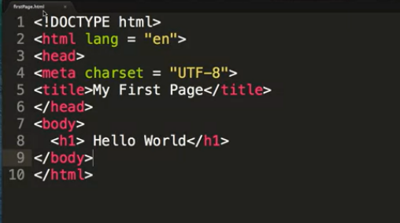

And now, while there are many times that I'm gonna force you to sit through and

watch me type horribly on the screen, this one, just to save some time,

I'm gonna go ahead and cheat and paste in some code that I've already written.

As you can see, I have my doc type, the head section and the body.

In the head, I've included my encoding and my title.

In the body, we're just going to say hello.

I went in and I saved it using Ctrl+S.

You can always do File > Save, but I find Ctrl+S is much quicker.

And for every editor you use there's these little helpful

keys to help you know wether or not you've changed anything.

So if you look right now at firstpage.html, which might be hard for

you to see, if I were to go in and change anything.

You actually get a little circle to let you know that you haven't saved in

a little while.

So I've gone ahead, I've created content and now it's time for me to open my page.

One way to do it is to head over here to my folder.

And oh, here's firstpage.HTML.

For me, there's a little icon of Chrome off to the side.

For you, it might be a different browser.

I'm going to go ahead and click on it and bring up my FirstPage, and I have success.

I cannot stress enough that most of the time when you type something at first,

it's actually not going to work for you.

For me luckily, I have the power of editing.

You have no idea that it actually took me a few attempts to get that file to work,

because I was messing around with some things.

Throughout the entire course,

I'm going to try to show you areas where you might have a problem.

Hopefully you won't,but if you do, they're all very simple to fix.

One of the most common problems is that when you right-click on the file,

instead of opening up nicely in the browser, it opens up your editor instead.

If you'd like to fix that, all you need to do is right-click on the file and

select Open With.

Another issue that happens quite a bit is that when you open up your file, instead

of seeing a nicely formatted web page, instead you actually see all of your tags.

When that happens, you need to check your file extension and

make sure that it says .html, and not something like .text or .rtf.

Another issue that happens quite a bit is that you change your code, but

your page looks exactly the same.

There are two reasons that this tends to happen.

One is that you have to do something called refresh your browser.

This just means you upload the contents.

The second thing that happens quite often is that you forgot to verify your

file name.

Let me show you an example of this one.

So let's go back to our original file.

As you can see, I have Hello World written here.

This is a very computer science-y type thing to say and

since I'm trying to seem more normal, I'm gonna change this to Hello Everybody.

I go in and I'm gonna Save my file.

Done.

Well, when I go back over to my web page, it still says Hello World.

It didn't change and I'm kind of upset about that.

So, now I remember it's often necessary to refresh your page.

There number ways you can do that,

you can typically go to the little circular area up here and click refresh.

You can right-click and click on Reload or you can also go to View, sorry.

You can also do it through the tool bar on top.

So, I'm gonna go ahead and refresh right here.

And you can see now I have the Hello Everybody.

The other problem I mentioned is that sometimes people change their file name.

So maybe you aren't working on your FirstPage any more.

So you decided I'm going to save this as File > Save As second page.

Save it.

I'm gonna go back over here and I'm gonna refresh the file.

Hello everybody.

Well, nothing happened.

You are gonna find this happening over and over and over again.

When you're dealing with a lot of files all at the same time,

you have to make sure that the one you're looking at on the browser matches the one

that you've been typing.

Because I changed the name of my file,

I need to remember to change it up here in the URL bar as well.

Boom.

Another issue that comes up quite frequently is this idea that you get,

what we'll call, weird characters.

One of the number one reasons for

this happening is my old favorite, copy and paste.

Whenever I give you code and you're looking at it through PowerPoint,

the problem is when you copy and paste it, a lot of the characters don't translate

exactly the way you hoped them to, and you get what we call weird characters.

The number one culprit is the quotes.

So whenever you're typing and you have some sort of weird thing you're not

expecting, go back in and try typing the code in by hand.

So I've shown you how to create and edit a file in Sublime.

But I wanna make sure that everyone has a chance to see

how I can create files using the editors that they have on their own computer.

So I'm also going to show you an example in TextEdit and also in Notepad.

I really hope when you watch these examples, you'll have your computer out,

and you'll type along with me.

Go ahead and pause, stop things, don't go ahead in the video until you feel

confident that you're at the point that I've reached myself.

Hi everyone!

Now we're gonna go ahead and make a file with TextEdit.

And if I wanted to be evil, I would go through and

show you a very quick, simple example of making a file in TextEdit.

But instead, I'm gonna be very honest with you and admit that it just took me about

15 or 20 minutes to figure out how to make a really simple file in TextEdit.

So first, let me show you what I did wrong.

All right?

I'm gonna go ahead and paste in my code for my very simple page.

Okay, let's get rid of this.

There we go. We've just got our header and our content.

So, you can type this in as we go along, or you can wait.

So it's time for me to save the file.

And what I need to do is I need to make sure I'm saving in the proper folder

with the file name.

So I am going to go ahead and call this FirstPage and

I am going to go down here and I want to make sure that I save this as a web page.

So one of the options is .html, so I am going to click on this.

I know have my firstpage.html,

it's in the folder that I want and I really feel like we should be good to go.

So I am going to go ahead and save it.

Now, I'm going to go over here to my web pages folder, open it up.

And it's going to open up in Chrome.

So, let's see how it goes.

That is not what I was hoping for when we were first taping this segment,

and it took me a really long time to figure out what was going on.

The first thing I went to check, let me close this up,

is I want to make sure that my file extension really had been .html.

And it was, there wasn't a .txt or a .rtf after it.

The next thing I went in and

checked is that all of my quotes were going the right way.

So let's go ahead and put these in, because if you remember,

I'm always telling you that copy and paste can sometimes give you bad quotes.

So we can go back again.

Still no luck.

If you're going to be using TextEdit, you actually need to go in and

make some changes to the TextEdit Program.

It has nothing to do with what you're typing.

It has to do with the TextEdit Program.

So I'm gonna go ahead, copy this just in case I lose it, and clear it out.

And I'm gonna go up to TextEdit, select Preferences, and

you can see that we have two options.

New Documents, and Open and Save.

So one of the first things I'm gonna say is hey,

whenever I have a new document, I would like it to be in plain text.

Not rtf, or rich text, but plain text.

The second thing that you want to do is go over here to opening.

See the display HTML files is HTML code?

We're going to go ahead and click on that.

And then lastly the most important thing is when you save your files,

we want to save it as utf8.

So I am going to pause here for a second,

just a second, while you look at your own TextEdit menu.

You want to make sure that you have these boxes checked and

you've changed it to unicode, utf8.

Okay?

If you've messed things up, go down to restore all defaults and try it again.

I'm gonna close this up.

I'm gonna go ahead and do New, paste my code in.

Ooh, that's very small for you, but that's okay.

Do File > Save.

And let's call it FirstPage2.html.

You can see right away it says, do you want to use HTML extension or

the dot text?

And I'm gonna tell it, use HTML.

Before I click this though I'm wanna point out that down here,

it's showing that it's going to save as unicode utf.8.

I can get rid of this warning, if I want to, by unclicking this,

if no extension provided, use .txt.

So we're gonna use html.

Let's go over here, let's cross our fingers, let's hope for the best.

And now I have a successful page.

So if you are gonna be using TextEdit, there's not really much you need to do,

except for the first time you set it up.

Make sure you go into the preferences.

From there I can now go in, make changes, we did it.

Save, and refresh.

So hopefully now you can successfully save and edit a file.

Okay, so let's say that you are using a PC to create your files.

What you wanna do is you probably want to use Notepad at first since

it's the free version of the editor that's already on your machine.

The first thing I did,

was that I made a folder right on the desktop where I can keep my files.

I know it's small, you probably can't see it, but it's called web pages.

If you don't know how to make a folder, just so

you know, you can right-click on the desk top, go to New and Create a folder.

Once you've created the folder where you want to save your files, I'm,

right off the bat, going to go ahead and say File > Save,

and I'm going to name this firstpage.html.

It's very, very important that you include the .html.

If you don't include that,

the computer's going to think you're just working on any other old type of file.

So I'm gonna go down here and change it from text documents to all files.

Go ahead and save.

Oops, it already exists, but I'm gonna say okay.

Now, it's time for me to put in some content.

I'm gonna cheat a little bit here and just copy and paste in my content,

even though you're gonna have to type it in bit by bit.

So again, I have my doctype, my HTML language equals English,

meta charset equals UTF-8, my title and my content.

Just to be safe, I'm gonna go ahead in here and put my quotes back in.

Because quotes always make me nervous when I do copy and paste, that maybe I've put

in some sort of character that my editor isn't going to recognize.

Now that I'm pretty happy and sure that I've got the things that I want in my

file, I'm going to go ahead save it again,

go into my folder, and click on the FirstPage.

And there we go.

So now, every time that you're going to change your file you can just keep

both windows open if you have the room.

Make your changes.

Job, I have a file.

Save.

And reload.

Nice job.

You've made a file using Notepad.

So here I am at the Shayhowe textbook, and

I'm on the section called Getting to Know HTML.

If you're like me, when you're reading things about programming,

you read them and you nod along,

even when you don't always completely understand what they were talking about.

And you wish there was some sort of example, or

a teacher showing you in real time what's going on.

Well, Shayhowe uses CodePen, and

that's one of the reasons I really like this textbook.

So let's take a look at what I'm talking about.

As you scroll down, you definitely that there is places where

there is code while you're reading, functions right here.

You can see that they're talking about the visions and

they've given a little text and it's HTML and

you understand the code but you don't really know what it looks like.

Well, if we scroll down a little bit further,

you'll come across code that's actually inside something called CodePen.

What you want to look for is this caption, right here.

It actually says Edit on CodePen on it.

So let's see what happens when I click on this link.

What CodePen does is it gives you a chance to see the HTML and

also perhaps the CSS and JavaScript.

I know that you don't necessarily understand CSS or JavaScript yet.

You may, you may not.

But you can still always play with all the different parts.

Let me make this a little bit bigger so you can see it.

And you can see that they've put in the code for

heading Level 1, Level 2, Level 6.

I'm going to go in there and I'm going to change it.

And I'm going to say what happens if I change this H3 to an H1?

Go over here.

You can see that Heading Level 3,

even though it says Heading Level 3, is much bigger.

I love CodePen and I really encourage you to always click on it, and go in, and

see what happens when you type things in.

You don't need an account, although you can definitely have one.

It's a great way to feel like you really understand and own the content.

Let's talk about writing clean code.

When I'm talking about clean code I'm talking about learning how to

write code that's going to work on as many devices as possible.

In order to do that,

you need to know a little bit about the document object model,

also called the DOM.

When HTML5 was developed

the main kind of driving goal is that they want to stick by the standard.

That any new features should be based on HTML,

CSS, the DOM, and JavaScript,

and you can have a chance to learn about each one of those.

But I want to talk about the DOM for just a little bit

because it's going to help you understand the HTML a little bit better.

One of the things about geeky computer scientists like myself is that we love trees.

Not like trees out outside that are green and beautiful in the fall.

We like mathematical trees.

These tree-like structures that we can prove to be valid or invalid.

So, when we talk about HTML as a tree we're talking about

this idea that at the very root of the tree we are going to be creating HTML.

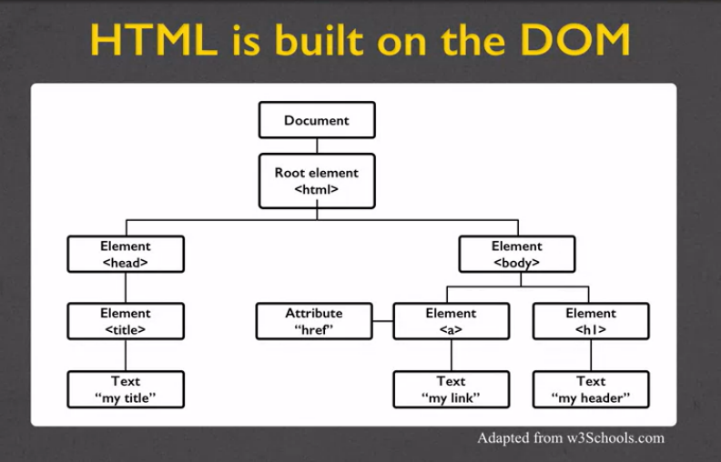

Then, from that tree when we say,

"I'm going to make an HTML document."

We want to parts.

We want the head over here, and we want the body.

In the head we're going to keep all that kind of

information that the user isn't going to see for the most part.

The one difference is we might talk about the title,

but we're going to have all of that kind of hidden stuff nobody really cares about.

In the body is where we're going to learn to put all of our HTML five tags.

So let's talk about HTML as a tree.

In this case I'm showing you this idea that at the root of

every HTML page should be what's called the HTML tag.

That kind of thing that says,

lets the browser know.

I'm going to be giving you certain types of tags and here's how I want them to work.

If we don't look at it as a picture,

I can also kind of just tell you that

every tree has three parts to a well-formed document.

The Doctype, which is the version of HTML that you're going to be using.

The head, which is all of the metadata or kind of extra information, and the body.

The body is the displayable content.

The thing that most people are going to get back when they do the request response cycle.

So let's talk doctype.

You are so lucky.

When I was creating web pages at first and we were in HTML4,

we had to come up with all these different ways to kind of explain whether

our HTML4 was very strict standards or whether it was transitional.

In HTML5, it's very simple to say,

"No there's only one thing and it's called DOCTYPE HTML", and you're all set.

For the head which is inside the head tag,

we're going to have all this additional information used by the browser.

So for instance you might want to say what language you're creating your page in.

You could also include,

and you really want to include what the title of your pages.

When I am talking about the title I'm not talking about big kind of header that you see.

I'm talking about the little tiny thing you see in the tab of your browser.

Later, you might want to add supporting files as well.

You might want to have CSS files that will style your page,

or JavaScript that can add on different interaction,

or really any type of add-ons that's going to

change the way people view and interact with your site.

Other than the title, the metadata is not displayed,

people will not see it.

What people do see is the information that's in your body tag.

That body tag is the bulk of your page.

So it's very important to write well formatted or tree-like

code where you're making sure that every tag has an end.

That you're not putting tags in weird orders.

So, most of the content in the body is displayed by the browser but

every once in a while there's a little bit of metadata in there too.

But we're not going to hit that in this class.

So let's look at an example.

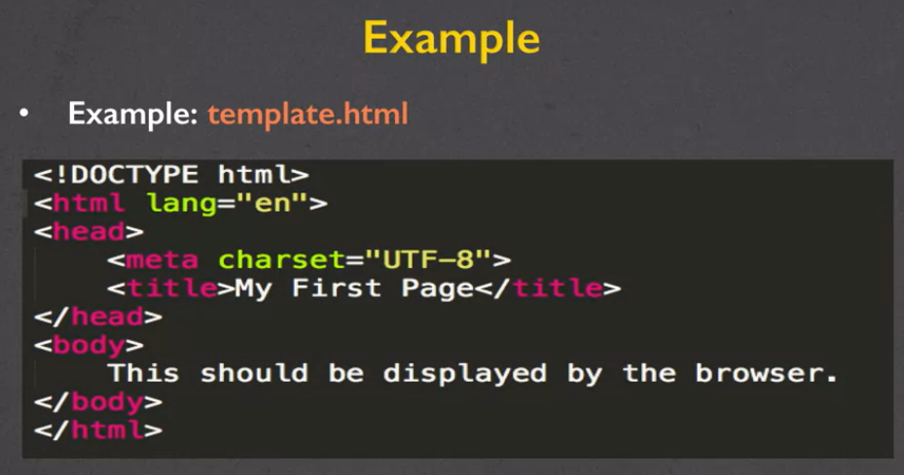

Right here, I have a file called template.html,

and I'm displaying the code here on the screen for you.

Can you find the three parts of a well-formed document?

The first thing you want to look for is the Doctype.

We've got that right here.

Letting you know that this is an HTML5 document.

We then have the HTML tag which was the root of our really scientific tree,

and I'm letting people know I'd liked the language that it's displayed in to be English.

In the head section we've got that metadata.

Where it's telling us things like, "Hey,

I know that there's lots of different keyboards

and ways across the world to represent letters.

I want you to use what's called UTF-8."

Don't worry that just use it every time.

Then the next part of my metadata is the title where we want to see it saying,

"My First Page." That's it.

That's two of the three parts.

The last part is the body tag and it's

displaying the content that we want to see on the screen.

So let's look at this in a browser. What do I have?

I have my title way up here,

and my displayable content right down there.

I have written the code,

the next step you should always do is validate the code.

Say, "I have written code it looks good,

but I know that browsers are very nice and they

make things display nicely even when I haven't written good code."

So if you go to validator, that w3.org,

{The address I use to validate my code is at <https://validator.w3.org/>.}

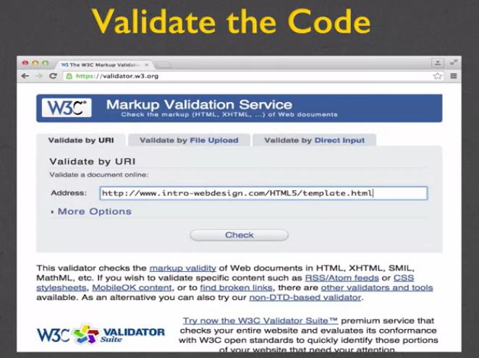

you can check any website to see if the code is valid and you have three choices.

You can upload the URL,

you can upload a file,

or you can actually copy and paste your code and put it right in there.

In this case, I've put in the URL to template.HTML run Check,

and yay, not surprisingly because I knew I

was going to be taping this, it successfully checked.

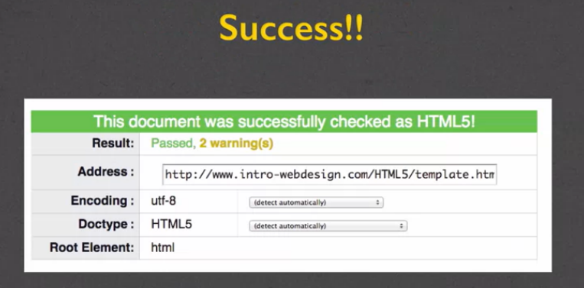

Don't worry about warnings.

Warnings are usually in to cover themselves.

What if you want to validate

your file but your files aren't actually on the Internet yet?

Let's walk through really quickly an example of how you can do that.

Let's say that I have my file template.HTML and I want to check it.

I want to point out to you that I went in and I changed

the file and I put in an intentional typo.

I spelled the closing tag for title incorrectly.

So let's see what happens.

And if the browser or the validator can find this.

What I'm going to do is I went to validator.w3.org,

and I'm now going to select the third option validate by direct input.

I go back to my file command A or control A,

if you're on a PC Command C,

I copied all the code and now I want to put it in the validator.

Hit check, up, and if we scroll down here I can make this a lot bigger for you.

You can see that I did get two errors.

Why did I get two errors when I only typed one error in?

Well, validators are never perfect.

So what error it found is it said,

"I found the end of a file and I was not expecting that."

Well the reason that happened is let's check out error number 2,

it tells us, "Oh you forgot to close the title tag."

So sometimes one error can cause a lot of error messages.

So don't worry.

I've seen as many as 50 or 60 errors that once

I corrected one line of code it fixed more than 80 percent of those errors.

So I'm going to go back over to my code,

I'm going to fix it and put that title in and save it.

Copy it again, put it in and I'm going to check again.

This time checking complete no errors.

So just to review,

you really want to follow DOM structure if you want a well-formed page.

Following that structure means you always use beginning and end tags.

Also you close inner tags before outer ones.

What that means is if you start

a title tag You've got to end it before you end the body tag.

You also will want to use

valid attributes which is one of the things we're going to talk about a little

later when we talk about images and

basically parts of your page that need extra information.

The problem with browsers is that they'll actually fix bad code for you.

I always call them the helicopter parents of coding.

It's like, "I know what you wanted it to look like so,

that's the way I'm going to make it look on the screen."

The problem is that doesn't always work for everyone.

So, just because your site looks good to you when you're looking at it on your browser,

doesn't mean it's right.

You have to use a validator to check your code.

# **Readings**

The readings come from **Learn to Code HTML & CSS: Develop & Style Websites** at <https://learn.shayhowe.com/html-css/>.

Some students prefer to do the readings before the lecture videos - they find it easier to listen when they recognize some of the words I am using. Some students prefer to do the readings after the lectures so that as they read they can connect it with what I said. Personally, I would suggest that you do the readings before **AND** after the lectures.

But no matter which method you chose, **make sure you do the readings before the quiz**. They go into more detail than my lectures and many of the quiz questions come directly from the readings. Also, make sure not to read the entire lessons for 8, 9, and 10. They go into CSS which we are not covering in this course. (CSS is the next course in this series.)

* **Lesson 2: Getting to Know HTML** <https://learn.shayhowe.com/html-css/getting-to-know-html/>
* **Lesson 8: Creating Lists** <https://learn.shayhowe.com/html-css/creating-lists/> (Only read up to "List Item Styling")
* **Lesson 9: Adding Media** <https://learn.shayhowe.com/html-css/adding-media/> (Only read up to "Sizing Images")
* **Lesson 11: Organizing Your Data with Tables** <https://learn.shayhowe.com/html-css/organizing-data-with-tables/> (Only read up to "Combining Multiple Cells")

This is it.

Today's the day, I'm finally going to teach you enough HTML that you can start

making an interesting page to share with your friends and family.

It's also, unfortunately, probably, or

at least hopefully, my first really big disappointment to you.

And the reason is, I need to just break it to you right away that

I can't teach you all of the HTML 5 tags.

I can't teach them all to you and you don't want me to teach you all the tags.

It would be incredibly boring for me to list them all off to you.

Instead I'm gonna get you started and

point you in the direction of where you can find resources for more tags.

Because it's really not until you need a tag that you

ever really bother learning about it.

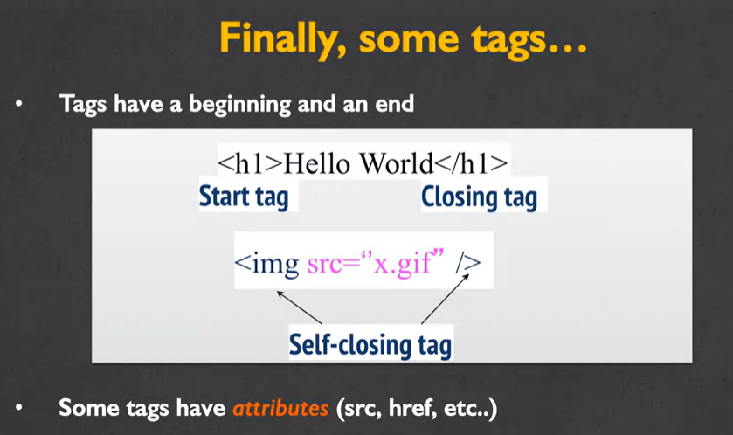

Every tag has a beginning and an end.

So, right here I'm using what's called an h1 tag or

a heading tag to encase the words Hello World.

The first h1 is my start tag.

It just shows the simple tag that I want inside brackets.

The second tag, the closing tag, always starts with a slash.

The indicates to the browser, she's about to end a tag.

This is one of the most common, is to have the start tag and

the closing tag, with some sort of text inside of it.

My next tag, or the image tag, is what's called a self closing tag.

There's only one tag, and it contains both the beginning and the end.

In this case, as soon as the browser see's the image tag, it knows

that you're gonna give it information that it can use to create a picture.

And since there's no real text associated with the image, at least at this point, or

any that you want to show on this screen, it's going to close itself.

So, while every tag has a beginning and an end, some do close differently.

Also, some tags have what we call attributes.

So the source which is where the picture is located,

an href which is where the new page you want to go to is.

So when we talk about the tags, for

some of them I'll also be talking about the attributes.

Before we begin, I want to talk to you about one

of the most important attributes in an element and that's its display.

The two most common display types are what are called block and inline.

Block tags are ones that take up a certain amount of width and height.

So anytime you have a tag that's called block, it's the same thing

as if when you were typing, you hit newline at the end, or enter or return.

Inline tags are ones that only take up as much space as is needed.

I'm gonna show you examples of both, but

I really want you to understand some tags are block and some are inline.

And it may not seem important now,

but it's the kind of thing that's going to make it much easier for

you when you're trying to make your pages look a certain way.

So some of the most common tags, includes the ones I'm about to tell you about.

Headings are block tags.

You have h1, h2, h3, all the way down to h6.

These tags have what are both called syntax and semantics.

To the browser, at first sight, it might simply mean, hey,

everything that's in an h1 tag, I want to make it really big and bold.

And things that are h6, I also wanna make them slightly bigger and bolder, but

not nearly big and bold as the ones of the lower numbers.

What a lot of people do is they just kind of randomly throw around h3 tags or

h4 tags just because they like the look that the text takes on it.

But these tags also have semantics, kind of a meaning that you don't see when you

just look at it, and the semantics are, things that are in an h1 tag

have much higher importance than things that are in an h5 or h6.

And this is very important for people who are using screen readers.

If you start throwing h3 tags and h2 tags all over the place just because you want

them to be a little bit bigger and bolder, it's gonna be very confusing.

Another extremely common tag is the paragraph tag.

It's also block, and inside of it you can only contain other inline elements.

So you can put a lot of text, a lot of pictures and things like that, but

you should never put a paragraph inside of a paragraph or even,

you should never put a heading inside of a paragraph.

Another common tag is the div tag.

This is a generic section that tends to be larger than a paragraph, and

it's related content that you would like to group together.

Div's used to be the most popular tag.

You would use the div for everything.

The problem with div's is that there's really no semantic meaning behind a div.

If you put a lot of them to your page you're not giving your readers or

users any extra information to let them know that this is a footer or a header or

something along those lines.

Two additional tags that you'll find you'll use a lot are the list tags.

If you put in the tag OL that stands for an ordered list.

By default it's going to put each list item as one, two, three, etc.

You need to make sure that you end each of your list items

before you start the next one.

And you need to make sure that you've ended all your list items before you

end your ordered list.

The unordered list is very similar, only instead of using numbers,

you'll use special symbols, perhaps the circle, or the small square,

depending upon your browser.

Now, later when we talk about attributes, I'll mention that you can go ahead and

change your ordered list.

So instead of being regular numbers, you're using Roman numerals, or

uppercase letters, or lowercase letters.

But by default, these are just going to either be a one, two,

three, four, etc., or some sort of little disc.

Finally one more tag that I know you're gonna see a lot of is the line break tag.

Line break is simply a br, stands for line break, and this is a self-closing tag.

Now one of the things that's very important that I tell you is when you're

typing your code you can put as many line breaks in your code as you want.

Enter, enter, enter, enter, enter.

But the browser ignores all of it.

The browser is not going to put something on a new line,

unless it runs out of space or it specifically sees the br tag.

So I mentioned before with the lists that tags can have attributes.

Attributes provide additional information about an element.

Sometimes they're absolutely necessary, sometimes they're just supplemental.

The important thing to remember is that attributes are always, always specified in

the start tag, in the beginning, and attributes come in a name value pair.

So let's go ahead and look at a tag that needs attributes in order to work.

I'm gonna use the image tag as an example.

Images are inline which means you can actually put many

images next to each other.

And in order for an image tag to work,

you pretty much need to tell the computer what picture it is you want it to show.

So in this case, the source attribute that indicates the browser

that the picture you wanna show is called myPicture.jpg.

Always notice that again it's a name value pair.

So the name of the attribute it sorts and

the value always goes in double quotes, and in this case is mypicture.jpg.

Many people will just end right there, but I don't want you to do that.

Images should also always include an alt attribute.

Alt stands for alternative text, and

this is what's going to show up to somebody who's using a screen reader, or

even if the picture is missing for some reason, because you've misnamed your file.

This will allow, if you have the little broken picture, some sort of text to show

up, to help people realize what it is you're trying to show.

So in this case, I have one tag, which you can tell because of the bracket, and

two attributes, source and alt.

Now speaking of images there's a few things I want to mention to you.

Images rarely work the first time you use them.

They're either gonna show a broken link because you wrote the wrong file name or

you forgot to upload it or it's not in the right file, or

the picture is going to be too big or too small or something like that.

Unless you have the broken link, and you're just worried about the appearance,

I want you to just let it go for right now.

What we care about right now is that you can get tags to work.

We're gonna worry about appearance later.

So if you really have your heart set on making things look a certain way,

then make sure that you open up the picture in some sort of editor and

save it to exactly the size you want.

And give it a really good name.

It's very frustrating to work on your web page when all of your files are named

image underscore 02586.

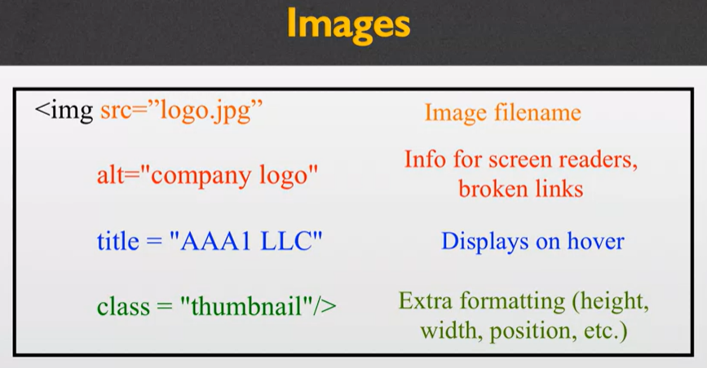

Here's an example for you of one image tag with multiple attributes.

I have the image tag, followed by source logo.jpg.

I have the alternative text, which is info for the screen readers and broken links.

I include a title attribute, which will often display when you hover over

the image, and then I also have a class attribute, which might

indicate extra formatting, such as the height, the width, the position, etc.

As you learn more and

more tags, you're gonna learn that they have specific attributes.

It makes no sense for an image to also include some sort of href.

It makes no sense for a link to include other attributes.

But there are some that apply to many of the tags, so I just want to mention them

to you quickly and we'll come back to them later in the class.

The first is, well, the class attribute.

What is does is it applies special properties to groups of elements.

We'll use that later when we want to say,

hey, we want to style all these pictures perhaps as thumbnails.

Ids specify a very unique id to just a single element on the page.

And you're gonna want to do this if you want to link back to it,

if later you wanna apply JavaScript to it.

But ID says,, hey this is a special part of the page,

you're not gonna find anything else like it.

Style is an attribute that used to be very widely used.

Style lets you apply visual style.

So you can put in special colors or spacing and things like that.

The next one is called accesskey, and an accesskey is very important for

accessibility.

It allows a shortcut key to kind of activate, or put into focus, an element.

So, maybe you have a big page and you have a form or something on it, and

you want someone to be able to quickly get to a certain part of your page.

You can give them an accesskey.

In the same way, some people may be accessing your page and

only using the tab button to navigate through your page.

If you do that, you're gonna wanna be careful about putting what's called a tab

index, and it lets you actually specify which order

people get to different elements in your page.

So even though something may come later in the page, if you feel it's really

important you can put a high tag index and them get there quickly.

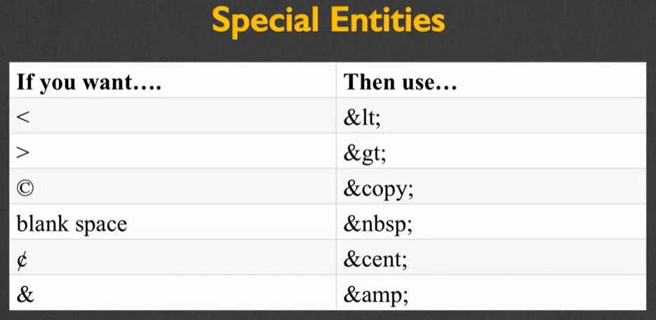

Okay, so one of the things I told you is that all tags start with a bracket.

Which is fine, that's very easy to figure out, and the browser knows whenever it

sees a bracket, it shouldn't display the content, it should do something fancy.

So what do you do if you want the browser to display a bracket?

And say, hey, this isn't a start tag?

Well, then you're gonna use special entities.

So if you want a bracket, then use & lt ;.

The lt stands for less than and please note that's an L, not a one.

You could also do & gt for >, & copy.

If you'd like extra blank spaces, you actually have to use a special entity.

Putting space, space, space, the browser ignores it.

You'd have to actually put & nbsp.

Again, if you want the cent, all right,

well what if you actually want an ampersand?

Well, in that case we even have a special entity for that, which is & amp.

So, we've gone through a number of tags today, and you're gonna learn more and

more tags and probably use cheat sheets and

go online to find a bunch of different tags you wanna use.

So an important this that I want you to know is,

how do you know the difference between a tag and an attribute?

And the key is to look for those brackets.

Also you're gonna want to make sure that you know which two symbols end

a self-closing tag.

All right. Don't forget,

that's where you have the forward slash in the closing bracket.

These are the kind of things that can really mess up your code when you try to

validate it later, and so being cognizant of these ideas in

the beginning will really help you write much cleaner code.

# **Cheatsheets**

There are many online "cheatsheets" for HTML. These files list all of the HTML5 tags, and also include information about tags that are common, but no longer supported by HTML. There are many cheatsheets available, but here is a link to one that is recommended by the W3 consortium webpage.

<https://www.wpkube.com/html5-cheat-sheet/>

Hi everybody.

Today we're gonna be talking about some of the newer HTML5 tags that

I like to refer to as the semantic tags.

This is going to continue our conversation about how we're trying to make our

webpages the most accessible as possible to as many people.

Before we begin talking about specific tags,

though, I want to talk to you about the design of your webpage.

Really, the most important step in your web design is the design.

Once you're down pat with the different tags and typing in files,

we're gonna change our focus to how you want to lay out your page.

And you need a really clear picture of what you want to create

before you can begin coding in earnest.

So let's take a look at this sample page.

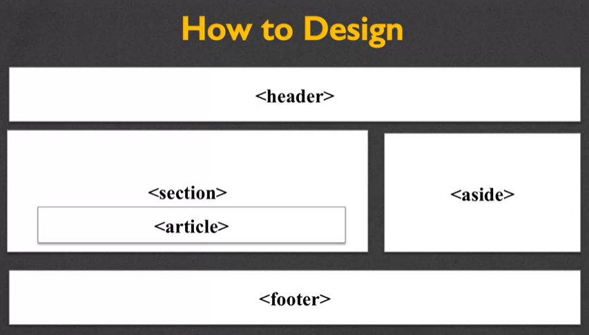

Again, it's just a quick sketch, and

it shows that I would like to have a header section, a footer section, and

a few other sections embedded in between the two of them.

Once I know that that's the kind of design I want, I can begin coding.

So you may recall that one of the most common tags used to be the div tag,

because in the beginning, kind of dum, dum, dum, you did everything with div.

You would go through your page, group it together, and

put each group into a div tag.

These divs almost always had some sort of special class or ID associated with them.

So for instance,

one div might have the class of header, another the section, another the footer.

This way, you could back to your design and

really break it up in a way that worked best for you.

The first tag that I'll be talking to you about today is the header tag.

The header tag is typically used to group together introductory or

navigational aids.

So you'd put in your title, perhaps your navigation bar,

anything that really lets the user know right off the bat what this page is about.

The thing I want you to understand about the header tag is that it is a block tag,

and nothing more than that.

There's no special formatting or anything along that line.

However, it does let the user know that this is the header section.

Now, most people will never see the tags.

Remember, the browser looks at the tag and

doesn't display it, instead formats its content.

But for people who are using screen readers or

other assistive devices, this is a great way for

them to find what they're looking for if they're not using visual clues.

Another point I wanna make is that the header tag

should not be confused with the head or different heading tags.

This is going to happen to you a lot.

Just remember that the head tag is for metadata, and

the header tag is more of just an aid.

The next tag I'm gonna talk to you about today is the nav tag.

The nav is basically a section of your page that links to other pages or

parts within your page.

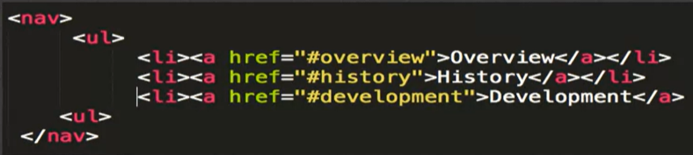

So, inside your nav you're not going to have links to Facebook, or Google, or

your LinkedIn account or anything like that.

Instead, it's really just links that go to other parts of your site.

So for instance, here I've made unordered list with three links.

Each of them go to a different part of your page.

There's a lot of debate, for better, for worse, as to whether or

not your nav tags should be using lists, but the important thing is to include

the nav tag to help people navigate through your page.

Oftentimes, you'll find the nav tag embedded inside the header tag.

Another tag is the footer tag, and this is a section that contains

information that is pretty typical for the bottom of the page,

such as copyright data, related documents, your links to social media.

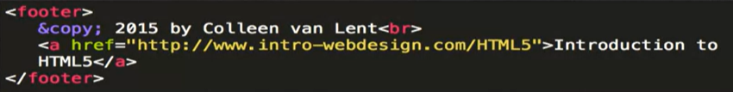

And while I say that it's usually at the bottom of the page, this is not required,

nor does using the footer tag actually make it that it'll show up at the bottom.

So in this example here, I have my footer tag, my special entity

to make the copyright symbol, and then my name with a line break.

And then I've also included a link back to my main site.

Some of our other semantic tags have a little more oomph to them.

So for instance, one of the new tags is the figure tag,

and it has a lot more semantics than the image tag we've gone over previously.

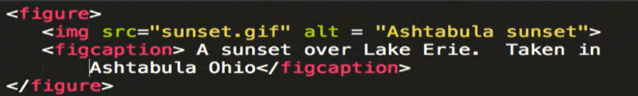

Every figure can include additional information.

So you can include an image,

you can include multimedia, you can include a combination of all of them.

But it also has some additional tags such as the figcaption.

So what this is going to do is somebody who,

it provides additional information for somebody who may not be able to see it.

So the picture normally just floats by itself when its in an image tag,

this lets you say, this text goes specifically with this image.

Now again, we do have the alt tag, which helps describe the picture, but

you have to remember, most of us will never see that.

There are a number of other new tags in HTML 5,

and it's not really possible for me to go over all of them.

Instead, you'll find that as you develop your pages and after you've done your

initial web design, you'll logically just head towards these different tags.

Some of them are structural elements, such as article, summary, sections, etc.

Others you won't be using until we create forms.

Another would be input types.

Have you ever noticed that sometimes on your phone,

when you click on certain buttons, different keyboards will pop up,

depending on whether you're typing in an email or a URL?

These are all things to the new HTML 5.

Email, data, color, etc., tags.

We're also gonna be able to talk about graphics elements such as canvas, and

also media elements which let you go ahead and put in your movies and

music of your choice.

The important thing to remember is that if you're developing your page, and

you find yourself using a lot of divs, you're going astray.

You really want to use the best tag available that will give the most meaning

to the users.

Semantic guide tags are gonna help guide your users to the information

in your page.

And that's really what you want to do,

you want to make your page the most accessible to as many people as possible.

Hi, everybody.

Every once in a while I like to stop what we've been doing, and

just do a quick check and make sure that we've all been following along, and

really getting a grasp of what we're doing.

So today, we're going to make a template page.

Today, I want you to create a page called index.html.

This page should utilize all those semantic tags that we've

been talking about.

The header, some sort of main, a footer.

And what I want you to do is I wanna make sure those elements are not empty.

Thirdly, I wanna make sure that your page validates.

So let's stop for a second, and think about all the things we've learned.

You've learned how to make elements.

You've learned how to validate them.

You've learned how to save your code.

So if you've only been listening and you haven't been coding,

now is the time to jump in with me and start coding.

So let's start with a shell.

If you remember, every webpage has three main parts.

It has your Doctype, which says hey browser, I'm gonna use HTML5.

It has your Meta-Data, which says, I'm gonna use this type of language and

this is what the title of my page should be.

And finally, you're gonna show your Displayable Content.

So, now's a time to stop, if you've been looking along on, on your phone or

whatever, I'd really love you to burst open an editor,

and start typing along with me.

So I've brought up Sublime, which is the editor I like to use.

And I'm gonna go ahead and start typing in my text.

The first thing I wanted to start with,was my doc type.

And for HTML5 it's super easy, because it's just doc type.

[SOUND] As long as I can type it correctly.

I've got that.

The next thing I said I wanted to put in, was the head or

the Meta-Data, and the tag for that, very simply enough is head.

Now if you've been following along as I code, you would know that

most of the time my code has this really nice kind of color signature to it, and

you can follow along with the different parts.

But right now all my text is just white.

The reason for this, is that even though I've begun an HTML file.

I haven't told my browser yet

that it's an HTML file, it's just any type of text to them.

So I am gonna go ahead and save.

And what I want to do is I want to call this, index.html.

The reason for using index.html, is that this is a convention known worldwide as,

this is the main page for my site.

So I'm gonna go ahead and hit save.

And as you can see, the colors have started showing up.

So let's go ahead and finish filling in my head element.

I'm gonna go ahead and put in my end tag right away,

because otherwise I tend to forget these things.

And the two things I want in here are the Meta-Data.

[SOUND] Oops, meta.

Eight.

And the all important title.

The title, again, is what shows up on the browser's little tab.

It doesn't show up on the page itself, it shows up in the tab.

[SOUND] I'm gonna say, My First Page.

Okay, I've gone in and put the head, and

now it's time to put in the body of my code.

Or my displayable content.

So I'm going to start with the body tag.

[SOUND] And I'm actually gonna go and

end my HTML tag while I'm thinking about it at the same time.

So this is an important step right here, where we decide,

whether we're gonna make accessible code, or just every day average code.

Accessible code is broken into parts.

You have your header, you have your main, you have your footer.

So at the very least, use a main and a footer here, letting our user know how you

can distinguish between the two types of content.

So when I put in main.

And I put in footer.

It may look like I have content, but really I don't have anything yet.

So I'm gonna save my file.

And I'm gonna use, open in browser.

And just take a look at what we've done so far.

As you can see, I do have that little part along the top that says my first page,

but what I'm missing is any type of real content.

It knows there's a main, and it knows there's a footer,

but there's nothing else really there.

So let's go ahead and put it in.

So I will put in a little paragraph tag that says,

this is my main code.

And down, oops, I shall leave it just like that.

And in my footer, I should put in some more information.

Think of a more interesting footer.

Okay. So I'm gonna go ahead and

save my page really quickly.

And let's go ahead and take a look and see if there's any, oops.

Wrong one.

And take a look and see if there's anything there.

Oh, there we go.

We have this is my man code, and think of a more interesting footer.

So it works.

My code works, and it's displaying the things I wanted it to display.

But as I mentioned, one of the things we wanna do every time we write code,

is we wanna validate it, and make sure we've written good, solid code.

So let's take a look.

I'm gonna open up a new tab, do a validator.

And I'm gonna do validate by direct input,

because I haven't actually posted my code anywhere.

So go back to my sublime.

[SOUND] Grab all of my code.

[SOUND] And put it in here.

I'm curious if you guys all noticed the error before I run it through

the validator, but let's check.

Well, at first you don't really see many messages.

But as we scroll our way down, you can see that right away it says,

the element footer must not appear as a descendant of the footer.

Well that's a kind of weird error for me, but let's take a look at it.

So, we wanna look somewhere along line ten.

And also, I'm gonna peek just a little bit at the next one, where it says end tag for

body seen, but there were Unclosed Elements.

So now I know there are two things going on.

There's something wrong with my footer, and something hasn't been closed.

Let's go to line ten.

Play video starting at :5:59 and follow transcript5:59

Alright, here's my footer.

Well it's unhappy about my footer.

Play video starting at :6:5 and follow transcript6:05

Oh here's another problem.

I have footer here, and footer here.

So even though I had multiple errors,

lets see what happens when I just make this one change right here.

[SOUND] All right.

I'm gonna go back here.

Play video starting at :6:25 and follow transcript6:25

I kind of do this the long way, but I always prefer it that way.

Play video starting at :6:29 and follow transcript6:29

Put in my code, And let's check it again.

Play video starting at :6:36 and follow transcript6:36

Boom. Even though I had a bunch of errors

before, everything is gone.

So I really hope you've been following along with me.

I really hope you've gone in, you've written some code.

You've remembered to use those semantic tags such as main, such as footer.

And you went back in and

you fixed any of the errors that the validator found for you.

This is really important.

You can't really know HTML5, until you jump in and start coding.

So if you've just been following along with me, go ahead make two files,

three files, four files.

Have some fun and really play with the one tags that confused you the most.

Because that's how your gonna understand them, and

feel confident about your coding.

Hi, today we're gonna be talking about images.

There are a lot of tags in HTML, and most of them are pretty self-explanatory.

But the image tag is one where we really want to explore it,

to make sure that you're using it to the best possible purpose.

So at this point, you've heard of a lot of different tags.

But images is one where you really need to understand

what the different attributes are.

There are many different file types that are supported by HTML.

The most common are: JPEG, GIF and PNG, and you're gonna see those quite a bit.

There's also SVG and BMP.

There are additional options.

The most important thing is that no matter which file type you use,

you need to include the different file extensions.

That's the .jpg, the .gif, the .png.

The additional thing to understand is that when somebody looks at your page,

every single image that you have on your page must be downloaded, so

size can really be a factor.

If you expect that most of the people viewing your page to be looking at it

from a mobile phone,

you might wanna think about using smaller file sizes, because every single image

requires an HTTP request in order to be loaded onto the browser.

So when we think about image sizes, most people think of,

just kind of, the visual how big it is on the screen.

But in computer science, we talk much more about pixel sizes.

By default,

the browser's gonna open up your image in the same exact size it's been saved.

And it's really, really rare that this size was optimal.

You've probably all gone to a site where you've gotten to it and

the picture was really small and you're not able to make it bigger.

Or perhaps,

what I find even more annoying, is when the picture takes up the entire screen and

you're forced to scroll around trying to see the whole thing.

So I'm gonna show you two quick solutions for changing the image size.

The first is to change the actual file, and the second is use the width and

height attributes for the image tag.

Now, if you're going to use and editor to change your file,

what you need to understand is that editors change those images permanently.

This only works on what I call local files.

You can only change the pictures that you have down on your computer.

If you're trying to use an image that you found someplace else on the web and

you're linking to it, you can't change the size permanently.

So if you're using a Mac,

there's built-in software called Preview that you can use to change the size.

And if you're using Windows, there's also a built-in program called Paint.

Either one of those gives you the option to resize your pictures.

However, just as a side note, neither one of these are the best

choice if you really want to get into different image graphics.

What most of us tend to do is use attributes.

Now, one of the things I talk about and

everyone talks about is the importance of keeping style and content separate.

And I really try to encourage people to not put any type of style

attributes into their code.

However, the image tag tends to be an exception,

because it includes both a width and height attribute.

So let's go ahead and walk through, and

I'll show you a picture of the site when we're done.

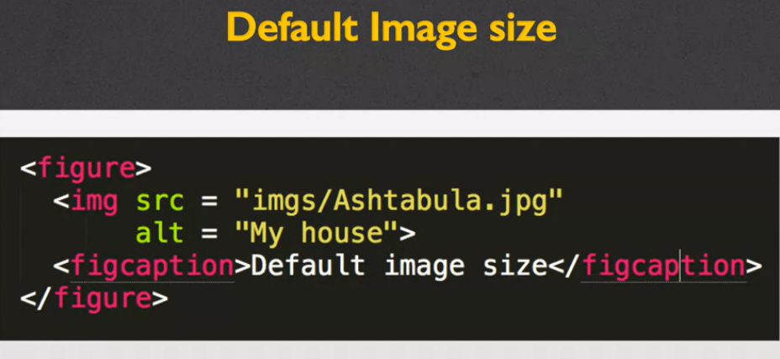

The first option would to be just use the default image size.

I have my image tag, and I have my two required attributes.

Source, where you can find the picture, and the alternate text.

The next option would be to use the width in pixels, so

in this case I've added the attribute called width and I've hardcoded it.

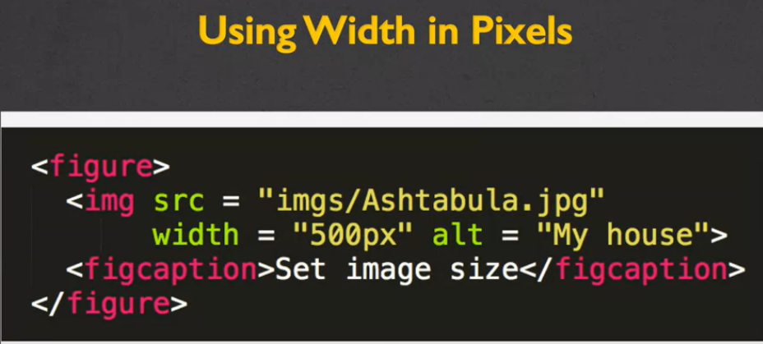

That's what you call it when you give it a size that you want it to always be.

And I've hardcoded it to 500 pixels.

You might notice that I've only set the width and I didn't set the height.

That's okay.

The browser will automatically figure out how much it should adjust the height so

it stays proportional to the width.

The next option is to use width and height.

You do this if you wanna make sure that your picture fits inside

an exactly sized box.

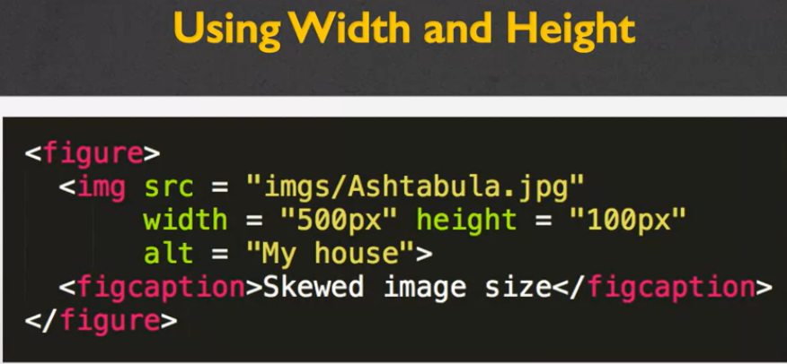

This is really nice for sizing, but it doesn't

always look the way you expect it to look, and we'll see that in just a second.

The last option, which may be your best option, is to use percentages.

In this case, if you notice, I have width = 50%.

What this means is, take how big the picture was going to be, and

reduce it by 50%.

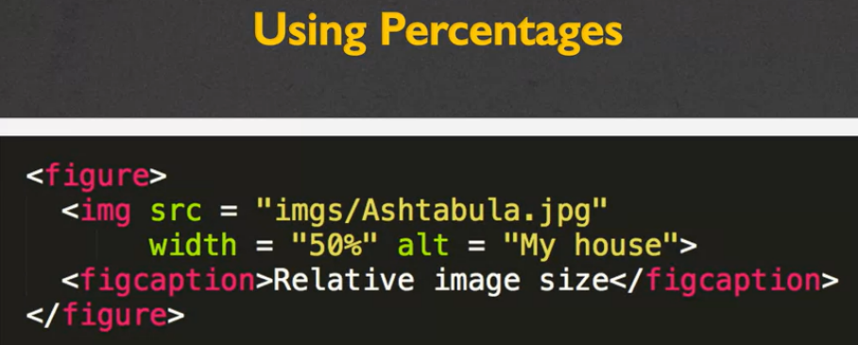

Now, as we get further on into programming and CSS, you'll understand that it's 50%

of what it should be, doesn't necessarily mean the original picture size.

It depends on if you're inside a container.

So here I've had each of the options, the default, the width, the width and

the height, and the percentage.

So let's go ahead and take a look at what that looks like.

So what you can see here are those four different options I had for

displaying my image.

Up in the top, I have my default image size.

This just happened to be how big the picture was when I took it.

One size down, and

you can see this is where I've hardcoded the width of the image.

I set the width to 500 pixels.

My house still looks perfectly nice, and everything is proportional.

The third option is the skewed image.

This is where I hardcoded both the height and the width, and

I didn't really put much thought into how they were going to act proportionally.

So by doing this you can see it's kind of squashed, and

not the best looking picture.

This last one is one I set proportionally, and

you can see that it's about half the size of the browser window.

What I want you to look at now is what happens when I resize the window.

So as I go here, you can see that the first three pictures stay

exactly the same size, but the bottom one will actually grow or shrink.

And this is the same if I make it smaller and reload the page.

So, thinking about different things along this line is how you want your page to

look when people might be looking at a large screen, or on a mobile screen.

It's something you wanna think about.

The last thing I wanna point out to you, that I'm gonna talk about in just

a second, is this little tiny picture that unfortunately,

it's very hard to see and there's not really a good way for me to blow it up.

But I want to talk to you about adding images into the title bar.

So if you wanna put a favicon into the title of your webpage,

it's slightly different then using a regular image.

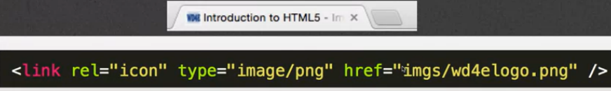

Instead, this code must go into the head section of your code, not the body.

What you do is you will actually go in and

you'll include a link saying it's an icon type of link.

We're using a PNG image.

And then you put the link to the image itself.

Just as a side note, you can't use JPEGs or GIFs for logos.

It either needs to be a special icon image or a .png.

Finally, let's go back to talking about alternative text,

the attribute that you want to add to all of your images.

What is the purpose of this, and why is it something we need?

Well, what it does is it provides a textual alternative to non-text content.

So any time you have an image, you wanna make sure

that people who can't see the image can still understand the content behind it.

So it might be read by screen readers.

Sometimes it's displayed in place of images, so if your file breaks,

you can still see a little note saying what they're supposed to be seeing.

Finally, it also provides semantic meaning for search engines.

So if you put really good alt text into your page,

it's gonna help search engines realize what the content of your page is.

So how do we create good alt text?

There are really four things you wanna look for right off the bat.

You want to be extremely accurate.

You wanna be succinct.

We don't wanna be redundant.

And we don't wanna include titles like picture of or graphic of.

So the first one, be accurate.

It's pretty self-explanatory.

Only put things that specifically define the image that you're looking at.

By be succinct, that means don't go on and on.

Really, it's supposed to be a quick kind of idea of what the picture's about.

When we talk about don't be redundant, what we're saying is,

don't include alt text that's already in the content of the page.

If you have the image, and in a paragraph beneath it,

you describe it in detail, don't put that same content into the alt text.

And finally, the one of don't include picture of,

graphic of, that really just goes back to just being succinct.

It is occasionally okay to leave your alt text empty.

So if you have images that are just decorative, logos, things along that line,

you can go ahead and just put alt equals and then the double quotes.

But it's very important that you don't skip the alt attribute all together.

The problem with going that route, is you don't really let people know whether or

not you were thinking about the accessibility.

They don't know if the alt text is missing because it's non-informative or

because you just forgot to put it in.

Okay, so let's go and review some of the things we know about images.

One, file extensions are incredibly important.

You need to make sure they match the file format.

The file name for your image is something that you're gonna want to

keep very short and descriptive so you can avoid using typos.

And finally the file paths, or where that whole long thing

that you put in the source where you have images/pictures/extension.

You wanna make sure you are spelling those correctly as well.

If you can do these three things, it'll make it easier for

you to successfully use images.

And for right now, let's go ahead and just style the height and

width right in the HTML code itself.

Even though I often talk about separating content from style, it's very common

practice to go ahead and incorporate those two when you're doing images.

# **Alternative Text**

Creating good alternative text is almost an art. The good news is that it is an art that even artistically-challenged people like myself can do well. The key is to think about the meanings behind your images, not a description of them. So here are some tips:

## Tips

* **Decide what information the image conveys:** Does someone need to see the page to understand your message? If not, you can treat the image as decorative use a null (empty) text alternative (alt=""). Make sure not to include a space inside the quotes since some screen readers may then read it aloud.
* **If the image is information, be complete, but concise**: In most cases you should be able to use a short phrase or sentence as alt text.
* **Prioritize information in text alternative:** Aim to put the most important information at the beginning.
* **Avoid superfluous information:** There is rarely a need to use the words “image”, “icon”, or “picture” in the alt text.
* **Handle complex images as a special case:** Complex images such as graphs, charts, maps, and illustrations contain substantial information – more than can be conveyed in a short phrase or sentence. In these cases, a two-part text alternative is required. The first part is the short description to identify the image and, where appropriate, indicate the location of the long description. The second part is the long description – a textual representation of the essential information conveyed by the image.

If you want to learn more about creating good alt text, I recommend the W3 alt decision tree site as a resource: <https://www.w3.org/WAI/tutorials/images/decision-tree/> This site guides you with simple "yes/no" questions on how to create your alt text.

In an earlier lesson,

you learned how to include images into your web page.

Sometimes though, people aren't really sure where to

find images or they're not very good artists themselves.

So today, I want to talk about using Font Awesome.

Font Awesome is a collection of icons that you can use for

your page and they're pretty much worldwide recognizable.

Here I am at the Font Awesome page.

I want to show you how to use it.

First thing I'm going to do is go to the icons selection.

As you can see, there are thousands of different icons that you can choose

from to help decorate your page and it's very simple for you to use.

The first step is that you need to tell your web page,

hey, I want to use Font Awesome.

In the getting started section of Font Awesome, they give you the code.

So let me show you what it looks like.

Here I am with a simple file.

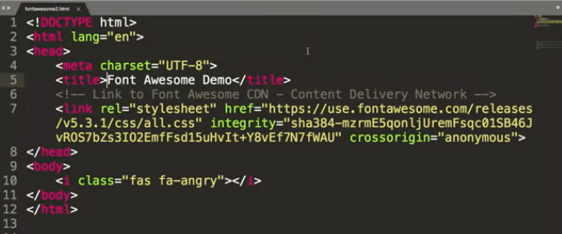

The only thing that's going to look new to you is that I have two unique ideas.

The first is that I have a link in the head section of my page.

Remember, the head is where we keep

all that extra information that isn't always seen by the user,

and what I've done here is I've connected to the Font Awesome CDN.

It's a very intimidating acronym that just means Content Delivery Network.

You're basically making an agreement where, hey,

I'm going to link and use your stuff but I'm going to use

this special link so you know how many people are using it.

If we travel down into the body section,

that's when you're going to see a new tag,

the i tag, it stands for icon.

Do you remember the image tag?

One of the things you need to have if you're going to use the image tag is the source,

what picture it is you want to use.

With Font Awesome, you have to include a class tag,

and in that class tag,

you're going to tell it which picture you want to use.

So in this case,

I'm using the one called fa-angry.

Let's go ahead and see what this page looks like.

Well, we ended up with an angry little person staring at us.

It actually is really straightforward.

You get a very little icon each time you include this tag.

Now, in all honesty,

my screen is blown up really big so if you were to run this code,

the icon would be really small.

So, let me show you some of the options you can do to adjust the size of your icon.

So what I've done is I've gone in and copied that line of

code a couple of times and in each one,

I added one extra attribute and that's the size that I want the icon to be.

So right here, I said make that icon extra small and then I did medium and large.

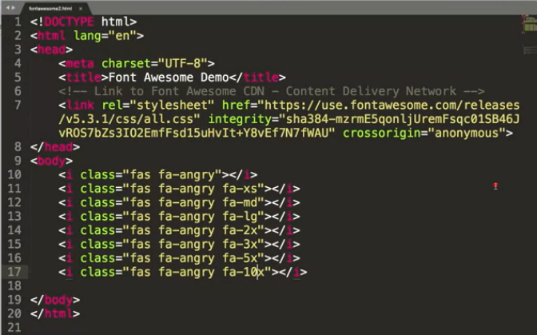

The 2x, 3x, 5x,

10x, etc, that's just making it that much bigger each time.

So now, if I look at the page again,

it's definitely going to look a little bit different.

In fact, it's way too big for the screen so let

me make it a little bit smaller, and there you have it.

We have the icons with different sizes.

Angry face clearly isn't the only one you can do.

Some of the more popular ones you might see include the address card.

So I'm going to copy it. It always starts off as the i tag with the class, equals,

you need to have fas for Font Awesome,

and then instead of angry,

let's go ahead and try an address card.

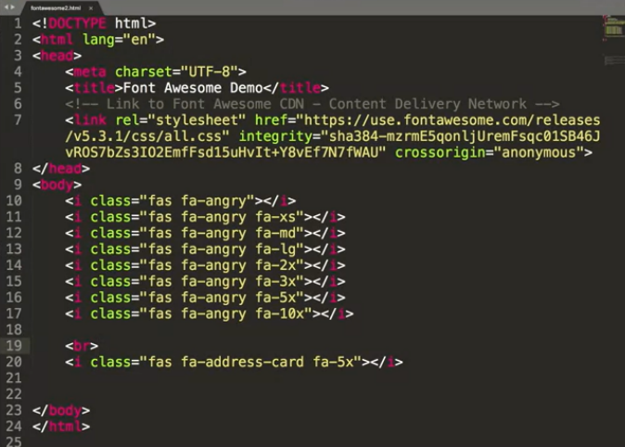

This one hopefully will look kind of familiar to you.

I'm going to put a line break in just to mix things up a little bit there.

Now, when I refresh the page,

you can see a very familiar little address card.

Icons are great because they give your page this kind of

really familiar look that people make it think it looks really professional.

But there are some downsides to using icons if you're not careful.

The most important being that they're not necessarily accessible by default.

So if you were to turn a screen reader on this page,

it would actually show up as if there's no content at all.

Or even worse, sometimes people use icons for social media links.

So let me show you one more example before we're done with Font Awesome.

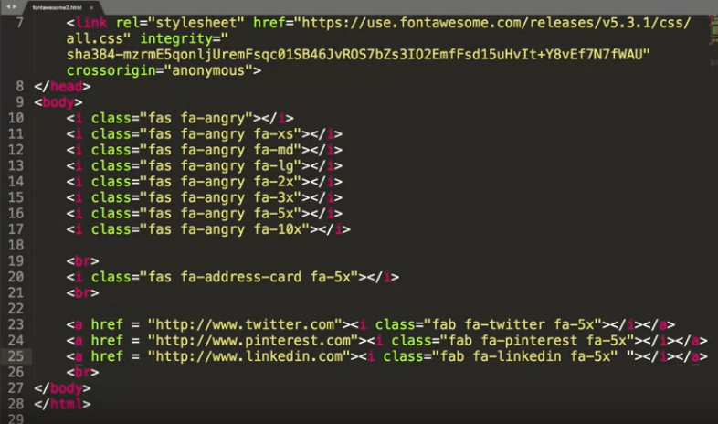

So what I've done here is instead of just using these icons as decoration,

I've actually put them into my site

so that if I wanted to say link to my Twitter account,

right down here, I would include the Twitter icon.

If I want to connect to Pinterest,

I could use this Pinterest icon right there,

and LinkedIn, and it actually looks really good. Let me show you.

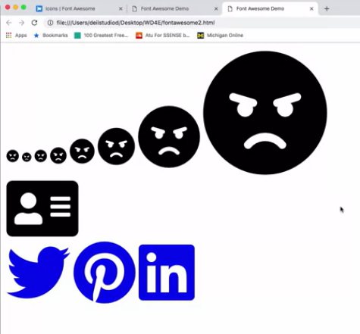

Here we go, I've got each of my links.

Just so you know, the reason these icons are blue is,

again, because they're links,

and on each one, I could click on it and it would take me to my account.

Here's the problem.

It looks great but I'm going to run

a quick Wave validator check on it to see if my code is semantically correct.

So I'm going to go to my hosted version.

Is it here? Let me find it.

So I'm not using the code I was just using because in order to validate,

I want to go ahead and put it on the server.

So I'm going to go up and I'm going to click on my Wave validation tool,

and wave is going to go through and give me three errors.

Not just any three errors,

but three very important errors,

and that is simply that,

hey, you have three links and they don't actually have any text.

Someone who's using a screen reader would have

no idea where this link is supposed to go to.

It doesn't know that this is Twitter or Pinterest or LinkedIn.

But I have a really simple quick fix for that.

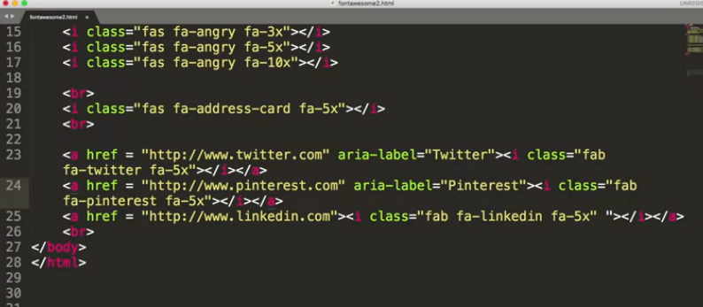

I'm going to use something called an aria label either in

my a tag or actually in the icon tag as well.

I simply put aria-label equals,

and in this case, I'm going to put Twitter.

On the next one, I can add aria-label equals Pinterest, etc.

By adding in these aria labels,

you're basically giving screen readers the ability to

tell somebody where this link is going to go to read a label,

and this is huge in terms of accessibility.

So I hope you have fun using Font Awesome.

There are so many different ones you can choose from

but if you're going to play with some of these cool tricks,

make sure that you're making them accessible to as many people as possible.

Hi, today we're going to be talking about hyperlinks, or links,

as they're more commonly called.

And how you can use them to link your document with others out there.

Now, links are really what make the web a web.

It's this whole idea that different links built together create this kind of

knowledge that search engines or you yourself

can gain by going from page to page to page, and with hopefully related material.

So, let's get right into how you create a link on your page.

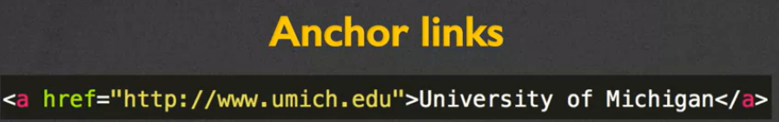

Links are called anchor links and that's where we get the a for in the a tag.

When you use an anchor tag,

the a tag you're going to need to make sure that you've two different parts.

You need a hyper reference and you need content.

So the hyper reference is just the reference to the location of

the new content.

So in this case I used http://www.umich.edu.

That tells a browser,

if somebody clicks on this link this is where I want to request the new page from.

We also need to have content.

The content is what we call the clickable part.

In this case, it's text.

I would actually click on an underlined text that says, University of Michigan.

But in some cases, it might be an image instead.

So what types of links can we have?

Some of the most common are called absolute links.

We also have relative links.

Internal links and

graphical links and I'm gonna show you examples of each one of those.

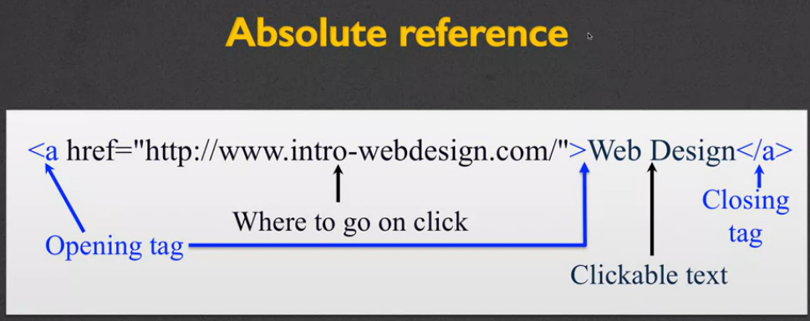

With an absolute reference in the a href section we need to put a fully formed url.

You need to have the http or https the address and

any type of extra document name you want.

So if you remember there's three parts to URL,

you have the protocol, the host and the document.

You need to include all of those if you have an absolute reference, right?

Everything else is still pretty much the same.

For a relative reference, we slightly change what goes in to the href.

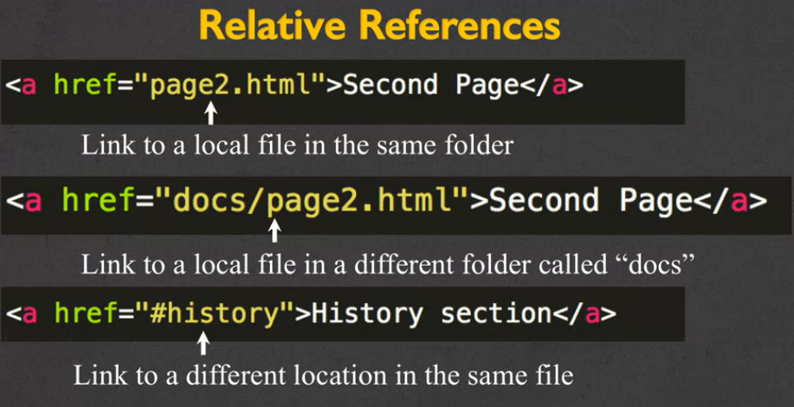

Instead of linking to some outside or

even internal webpage, we're only going to put, in this case, the file name.

So in this case we're going to link to page2.html.

You might get slightly more in-depth than that,

where you can include also some sort of folder name.

So in this case we'd be going to the file called page2.html but

it's in a different folder called docs the third

way we can use a relative reference is to what we call use the ID tag.

So when you have href equals hash pound or history, we're

saying there's another location inside the same file and it's called history.

So, absolute versus relative links.

When would you use absolute links versus when would you use relative links?

With absolute links, you're basically saying, I am not in charge of this page,

somebody else is.

So if you're linking to somebody else's page,

absolutely use the absolute link with the full reference in there.

For relative is when you're developing your own site.

And it's really helpful to use relative links instead of absolute, so

that way if you move your page to a different server,

or you move it into a different folder, you don't need to rename everything.

And so those are some of the benefits to using local links,

is just the idea that you don't need to update as much.

Now, one of the things that you need to make sure that you never do

is have a link that includes some sort of file structure, we'll call it.

So check your links.

Make sure that it never says, C:page or MyDocumentsPage or

anything that is very specific to your computer.

The reason that you don't wanna do that is.

If you put your page out on the web.

If you're done you've put it up on a server or a hosting and

you want other people to click.

Well, it doesn't make sense that they would be able to access pages that are on

your computer.

So never ever have a reference that includes something local to your machine.

All right? One of the other things that you can do is

you can use images as the link.

So the clickable component doesn't have to be text.

You've seen this a lot.

It can be icons, images.

different things along that line.

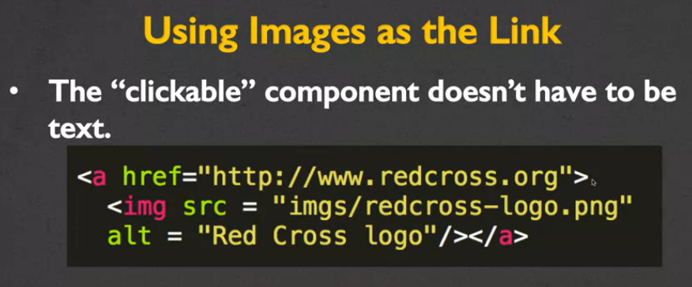

In this case, I went in and I use the regular H reference and

what we're changing now, is not the h reference, but

content that goes between the opening and closing tag.

and I have gone ahead and I've put in an image instead.

Make sure that you use the alt text to go along with that image.

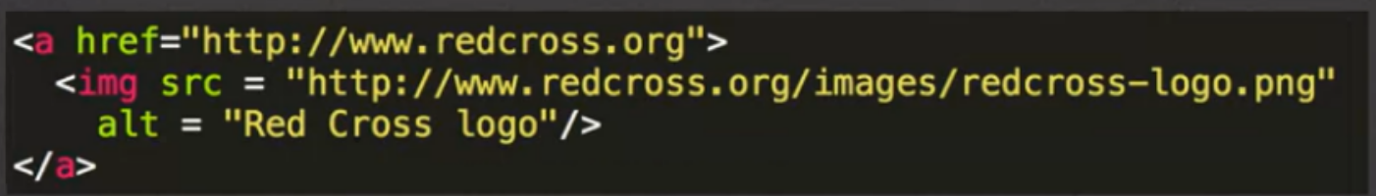

And another case I've done something very similar,

the only difference is, instead of using a local reference right here for

the image, I've used an absolute reference.

I've put in the entire URL.

So let's talk usability issues and accessibility issues.

If you're going to use a clickable component,

you wanna make sure that it has an informative name.

There's software out there that can list all of the links within a page for

people who are looking for things, who can't use typical.

typical means of accessing the page.

It is not at all helpful to them if all the links are labelled, click here,

click here, click here, right?

You want to give it some sort of informative name.

You also want to make sure that if you are using an image for

the clickable portion of your link.

That image needs to have some sort of alt text or

other information available to those who can't see the image.

So, let me show you some coded example of those types of links.

All right?

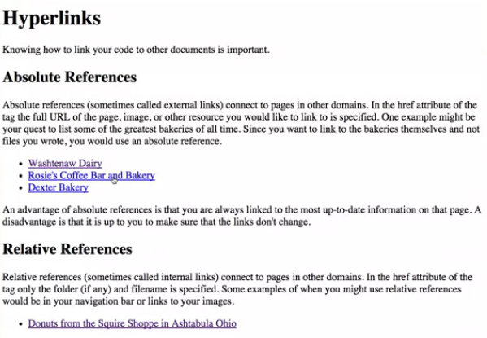

As you can see here, I have a reference to absolute references,

relative references, images as links, and then some embedded links, as well.

So, if I were to click on Washtenaw Dairy or Rosie's Coffee Bar and Bakery, or

Dexter's Bakery etc., it would actually take me to their pages.

Ahead back.

One of the tricks I want to point out as I'm doing this is,

as I hover over each one of these links, if you look at the very,

very bottom of my browser, and I can't really show at the same time, but

as you highlight it, it shows you which URL you are going to.

And I think this is very valuable for

people to know, because if you're ever hovering over a link, and

the information you see at the bottom of the page doesn't match what you said.

So absolute references take you away from your site.

Relative references can take you to something that's within your folder.

So right here I have an image of some doughnuts, and I have gone on and

they're in my folder in my file.

So I was able to link to them just using the picture name.

All right?

We can also use images as links as well.

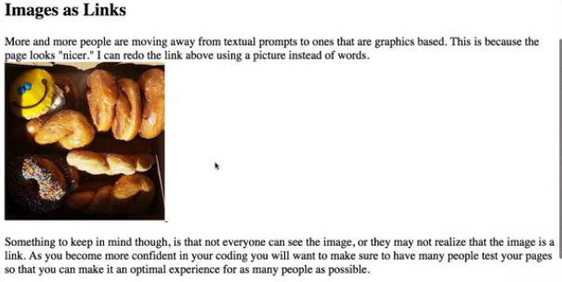

Instead of writing Doughnuts from the Squire Shop, I went ahead and

made it so you can click on the image to get to the larger view.

This last idea of embedded links is a little bit interesting.

So let me bring you over to the code for just a second and show you.

Write down here,

I have something called relative references with an ID equals relative.

I have embedded links with an ID that says embedded and

up here, at the very beginning you can see I have div id = "absolute".

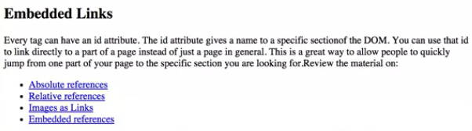

With embedded links, I can click on any of these and navigate within the same page.

So I'm not gonna go to a different page.

I'm not gonna open up a new tab.

Instead I'm gonna jump to different places within the page.

So I went to absolute.

I went to relative now if I try to do embedded references

it doesn't look like it moved but it really did.

It's just that we're already there.

All right, so that is how these kind of embedded or internal links work, right?

Now if at any time you get confused about how code is working.

I just want to remind you they can always go to view.

Developer and view source to really get a better idea

of how people are creating their pages and their links.

Next, let's talk about targets, all right?

Anchors can take a different target attribute as well.

We've got the source, let's add anchor.

So we're target.

So you might have target equals self.

This is kind of the default action.

This is going to happen if you don't put anything at all.

If you don't even include target, and what it means is when you click on a link,

open up in the same tab or window that you're looking at right now.

If you put target equals blank.

You're going to leave the current page you're in exactly the same, and

open up a new tab or window for where you want the new page to be opened.

Now this has its upside and downside.

The upside is that your site is still open in someone's window.

The downside is that many people don't like it when it keeps adding on and

adding on, and

as they progress through your page, you're making them open more and more tabs.

There are two other options that we're not going to really talk about here, but

you can see them in the reading, and those are top and parent, and

that deals with if you're really getting into the idea of having multiple windows,

frames, etcetera open.

So, let's go ahead and review, because making sure that you understand links is

vitally important to your success in this course or even in just understanding HTML.

So, the first thing you need to know is a page without links is extremely rare.

And to be honest, it's almost not even a web page.

It's just a document.

Links can be absolute, relative and internal.

And internal, again, was the kind where it had the hash mark in it.

I think I may have referred to them as relative, but

I wanna make sure I'm clear that the hash mark makes it internal.

You want to use caution when using images in links.

It's not that they're not a great thing to do, and I'm not saying you should do it.

I'm just saying make sure that you do it carefully to ensure that everyone who is

viewing your page can get the same content and the same experience as everyone else.

Hi, in this lecture we're going to talk about multimedia.

This is including video and audio into your website.

Now video and audio are two of the most popular and

two most hated elements of the web.

Designers love it because they get to put their cool videos and

perhaps some homemade music online and share with everyone.

People accessing your site sometimes hate it because they feel like they don't have

any control over what they're seeing.

So, what we're going to talk about today is the HTML5 audio and video elements.

We're going to briefly explain the purpose of plugins.

And then finally, we're going to reflect on the accessibility issues

that come hand in hand with using these types of multimedia tags.

So before HTML5 there weren't really any consistent uses of multimedia

that were being held across all the browsers.

So the new HTML5 is designed to kind of avoid the use of having to use plugins or

extra software that you don't already have on your machine.

It should really be plug and play.

If you're gonna put in a video, people should just be able to see it without

having to download Quicktime or Flash, or anything along that line.

Now it's not a fully implemented tag yet.

But it's moving very quickly in that direction.

So let's start with the video element.

So the video tag uses a source attribute that is very similar to

the image attribute.

You tell the browser where the file is.

You can also use what we call embedded tags,

where you might have the video tag and then multiple sources down below.

There are a number of attributes that are used very widely.

The first two, height and width, are pretty self explanatory.

How big would you like your video to appear in the browser?

Autoplay dictates whether or not the video should start as soon as you load the page.

Loop will allow the video to play over and over.

And the last one, controls, is something you can add to give the person more

control over when to stop and start the video.

If you use a video tag, it's usually a really good idea to put some

text in there along with the different attributes.

That way, if the browser for some reason does not support the tag or

can't play the video, you get a kind of helpful hint to the user letting them know

there should be a video here that you would be looking at.

The audio element is very similar to the video, and

then again we use a source attribute to link to the file.

Typically, you're going to use a .mp3 or .wav file.

The attributes again, very similar.

You have autoplay, controls, and loop, but we also have buffered, muted, and volume.

And these are the extra attributes you can put in where you're going to control

what the person's listening to and how loud.

Also when you're using audio, you can set clips where you can go in and

say, I want the video to start at this particular time.

So my first example, I want it to only play the music from 5 to 25 seconds.

The next one, you start at the beginning and

you only are gonna play the first 39 seconds.

Again, you can go on and on.

I want to start at one minute 38 seconds, and just go ahead and play to 45.

Or in the end you can just say, hey, start at the 42 second and play from there.

So showing you the code for HTML video and

audio is pretty much the antithesis of what it's all about.

It's supposed to be about looking at things and hearing things.

So let's go ahead and look at some code now that's actually working.

You can see that I have the src as just my BoxCar movie, and

I've set the default width to 40.

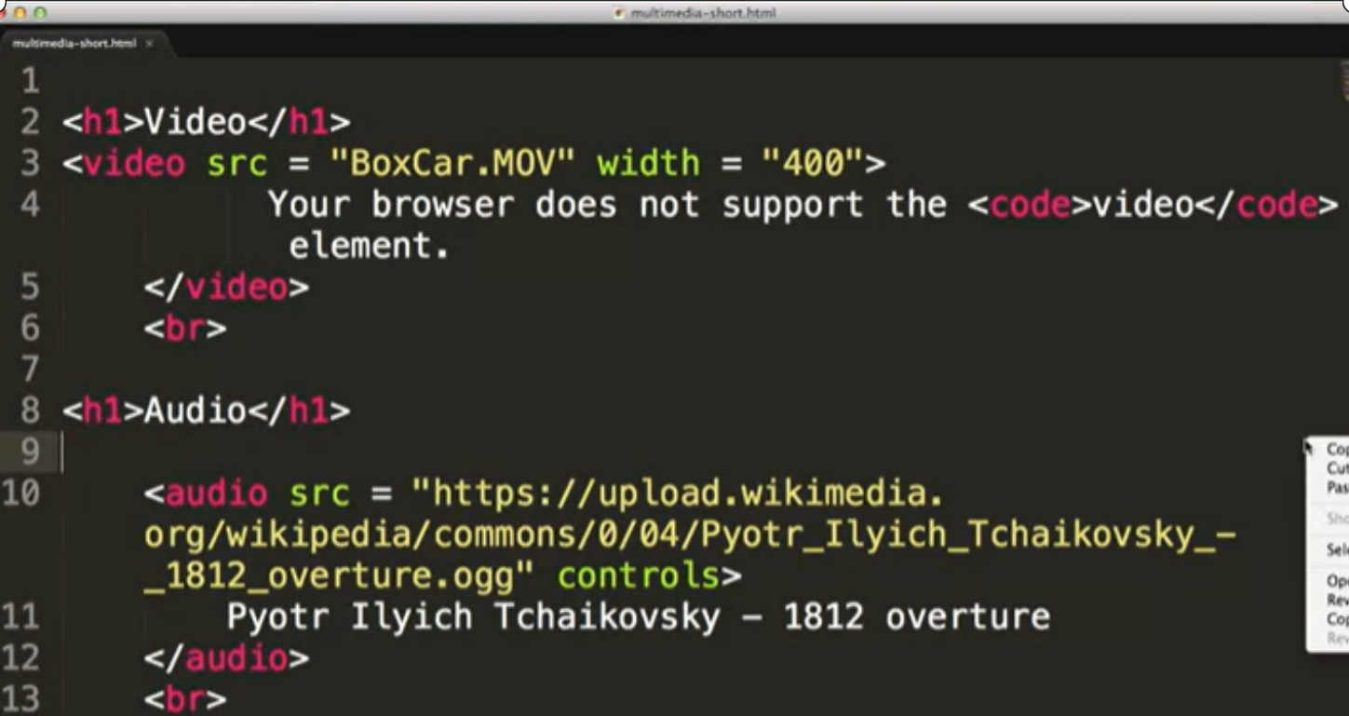

So, I'm gonna go over here to Sublime and open this up in the browser.

There it is, and it's not very exciting.

Unless you have super quick eyes and your browser is incredibly fast, you completely

missed the fact that it loaded this video and played all the way through.

So let's go ahead and try this again.

Actually, it just loaded it and didn't do anything.

Let's add autoplay.

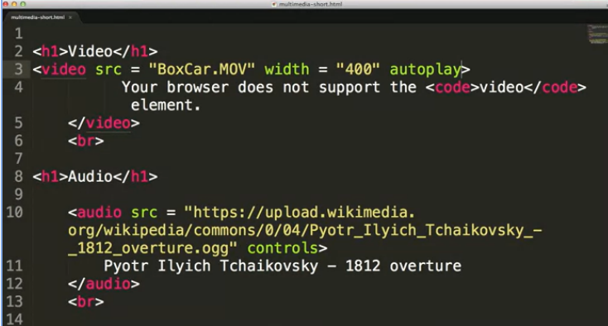

All right, save it.

I'm going to go over here and reload, and now you can see

by adding the autoplay attribute, it'll automatically show the video.

Now this is something you don't want to do unless you're very certain

that the viewer wants to see it.

There was a big uproar recently when a social media site

started making all of the videos autoplay.

So if you went on, all the sudden all these videos were playing.

And it was eating up a huge amount of bandwidth for people, all right?

So, instead of just doing autoplay, let's go ahead and put in controls.

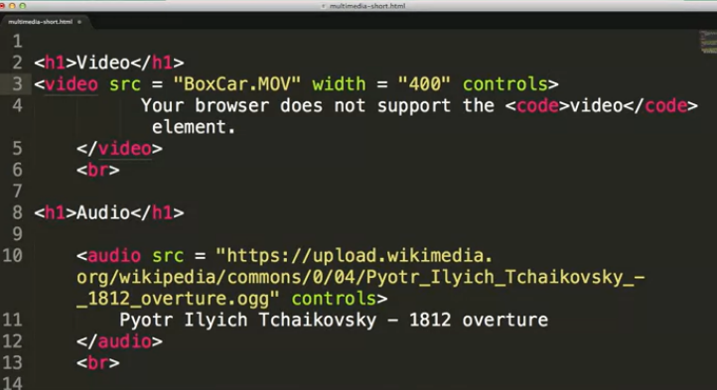

By doing this,

you can see we've now added a little control panel to the bottom of the video.

People can now start the video, stop the video, and rewind it.

This is really the way you kinda wanna think about

how you can enhance the experience for the user.

It is possible to put multiple attributes

into this and kind of put them on top of each other.

If we do this now, you get to experience my

five year old flying down the road multiple times over and over again.

Again, you would really want to avoid using loop and also avoid using auto-play,

unless you're giving people the opportunity to use the controls as well,

all right?

One last thing I want to talk about here is you might notice with controls and

loop, these are attributes that don't appear to be taking any values.

So src =, width =.

When you put in these boolean attributes,

it's the same thing as saying controls equals true.

Loop equals true.

So that's how we went through with our video.

Let's go ahead and look at the audio for a second.

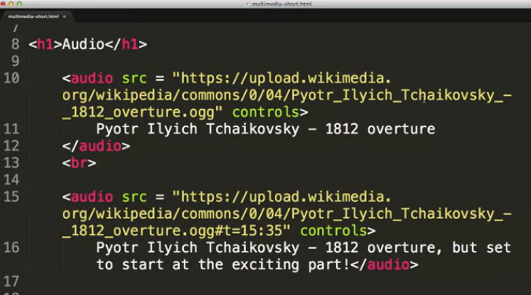

What I have here is I just have a link to the same song two times.

In my first version, you can see that I'm given the little audio bar,

because I made sure to use controls.

And if I'd play, it's going to go ahead and play through the whole song.

However in my second option, you can see I've added, right here, the t=15:35.

I've set it up for you so

you'll really get to hear the song from when the exciting part really kicks in.

So these are just some simple examples of how you'd use the tags to show your

video audio.

And I really hope that as you're coding, your making sure to type things along, and

mess with things, and play with things to really get a feel of how these videos and

all the different HTML5 tags are working.

So one of the things I talk to people about, who have been coding in

other versions of HTML and don't really want to make the change over to HTML5.

That there are so many reasons that you want to make this quick simple switch.

And plugins are an excellent example.

Since before HTML5, there was no standard, plugsins were required.

So what we want to do is go ahead and

even if it's not supported at the moment, go ahead and use this tag,

understanding that some browsers my still require Flash in order to play them.

Finally, let's talk about accessibility issues.

When you're going to use video or audio, just like with any type of non contextual

content, you want to make sure you provide any type of text descriptions and

closed captioning or other equivalent content.

You want to make sure that you also provide any links to plugins.

Otherwise, you're pretty much just left with some sort

of blank little broken icon that people don't always understand.

And finally, the most important thing I'd like you to take away from this talk,

beyond being able to use the code,

is that multimedia should really enhance your content.

You don't want it to be a distraction.

You don't want people spending time trying to figure out how to turn it off so

they can, in order to really get to the content of your page.

Thanks.

Hi, today we're gonna talk about tables and

how you can use them to display your data on your website.

So, how I like to put it,

is that we really used to consider tables as being this evil kind of idea.

Because people weren't using tables for the reason they were supposed to.

Instead, they were using tables to kind of set things out,

laying them out nicely on the screen.

This started to happen back during the time of HTML 2, maybe HTML 3.1.

And people said, I really want my page to look nice and

I don't have a means to do it, so I'm gonna make it a huge table and

kind of lay everything out in different rows or columns.

This completely throws out the whole idea of separation of content from layout.

In addition, it makes it really confusing for people who might be using assistive

devices, because they're wondering, is this really all a bunch of data,

or is there content that should just be kind of formatted in the regular way.

So we're gonna start talking about tables.

And what I really wanna do is stress the idea that you should only be using

tables if you have some sort of data being displayed.

Now before you even start coding a single thing,

I need you to sketch out your layout of what your table should look like.

Now, I've told my students this over and over again, and they say yes, yes, and

then they start to code.

And then they say yes, yes, and then they start to code.

And, after about the fourth or fifth time, they realize,

oh, it's a lot easier to write clean code the first time, than to fix broken code.

And so, then they begin and they think, alright, how many rows and

columns do I actually need to represent all of my data?

And then you go a step further and say, well are there any rows or

columns where I actually need to span multiple cells, or

what we call the little boxes in the table?

Because if so, it's gonna be a lot easier if I've drawn this out to figure out

where I'm gonna need any special attributes to make that happen.

Because one of the most important things to know when you're doing tables is that

the browser's expecting there to be the same number of cells on every single row.

If you don't do that, it's going to look very messy.

Once you've decided what your table should look like,

then it's time to start thinking about the tags.

You start out with the table tag and it's basically just a container element that's

going to hold all the other attributes and all the other tags inside of it.

You're gonna have the table row and then here for td, I have columns, but

what I really think would be best is to think of this as table cells, not really

columns because what you're doing is your talking about each individual box.

So inside the table, you're gonna have one or more table rows.

And then inside each table row, you're gonna have one or more TD elements, so

the columns or the cells.

So here's the code for creating a very simple table.

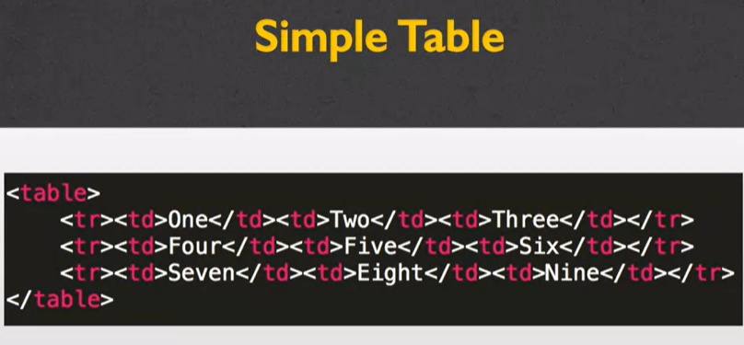

Although it looks very convoluted and like there's a lot of things going on here.

Most of this is just information for the browser.

When we look at the actual page that's generated you will see that it's very

clean and simple.

So I have my code for

my table on the outside and then each one of my lines of code here is one row.

I have my tr start and my tr end.

And then inside each row I have three elements, one, two,

three which are inside the td tag.

And I'm gonna tell you right now that when I initially wrote this code It looked

fine, but I kind of messed it up because I'd forgotten to put in my ending tag.

So make sure when you're coding these, you're being very clean and concise.

And if you do it correctly, this will create a simple table,

as I said, with nine elements in it.

One, two, three, four, five, six, seven, eight, nine.

This is as simple as you can get, as far as the table goes.

Now in some cases you might want to add what we call table headings to your code.

Table headings is the idea that at the top of each column, or even at the top or

the start of each row, you have some sort of text that is bold, that indicates

this isn't data, this is actually the name of the data that we're looking at.

Now It's fine, I mean it's not fine, but what some people would do is they would

just make these regular TD elements and perhaps make them bold.

So the people that are looking at it can say, oh hey look.

This is bold so it must be more important.

But we really want to avoid doing that.

Instead of using a TD with some sort of bold font,

we want to use a semantic tag TH, which stands for table heading.

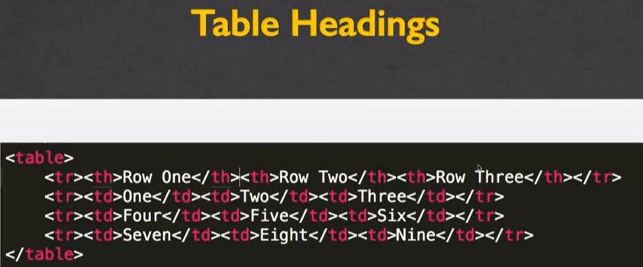

So here these three lines of code are exactly the same as before, but

I've added one new row, where instead of td I have th.

So I have row one, row two, row three, etc.

And what you can see here is that what we get is this nice little table

heading at the top of each one, that is both visually lets the user know that

these are headings, but also semantically conveys that same information.

So one of the things I mentioned earlier, when you're designing your table

is you wanna decide if you're gonna be spanning multiple cells.

It might be the case that the table you wanna make isn't some sort of

perfect tic tac toe grid, or perfect nine by nine.

So you can combine multiple rows and or

multiple columns using the rowspan and column span attributes.

Inside your element you would include rowspan equals two if you wanted to span

two rows, or column span equals five if you wanted to have it span five columns.

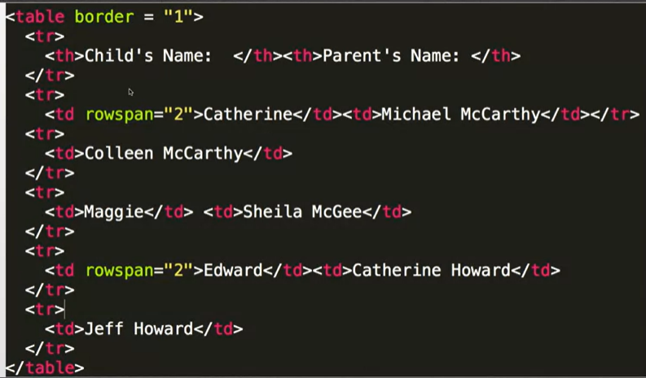

Alright so let me go ahead and show you an example with some code and

again, I realize that if you're looking at this on some tiny little screen that this

seems really like a lot of information to digest in.

But it's not really that much going on.

I have a simple table, where I have my table headings with the Child's Name and

then the Parent's Name.

And then I go ahead and I start putting in a child, and

with each child, I include their parents.

So here, I have rowspan equals two for Catherine,

which means I actually want my Catherine cell to take up two lines.

Same with the Edward cell.

Maggie I've left completely alone.

So let's just go and look at the end result, and I think that's really if

we backward chain, it's going to help you understand what this code is doing.

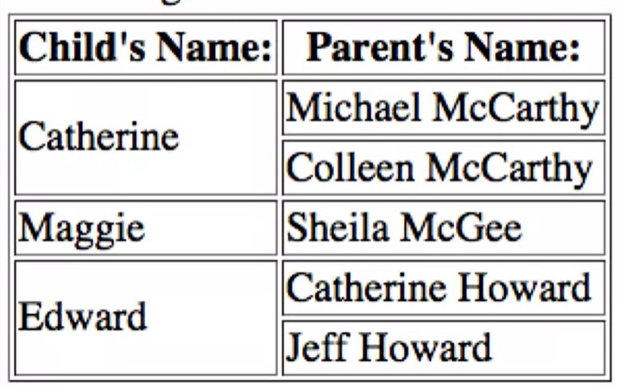

So again, I have the child's name and the parent's name, and

here are the two cells where I did the row span.

And you can see, it actually took up Multiple rows because in this case,

Catherine and Edward both had two parents that we wanted to put it together with.

Again, not a hard concept, but it is the case that if you weren't thinking about

it, and we went back to your code and just started throwing rowspan and

columnspan in, it just gets very messy and harder to debug.

One of the things you might have noticed,

at the very top of the table, I included a border attribute.

The reason I did that is because I think it's much

easier to see this rowspan here because I have the lines around each cell.

So, you can use the border attribute to go ahead and

put lines inbetween each one of your cells.

And it's very common to do that.

But, again, in your HTML, I try to avoid styling.

It's something we can add later if you decide to learn more about CSS.

But it's an attribute that's so commonly used, I wanted to go ahead and

put it in there so you could see what was going on.

Next, let's talk about captions.

So, how do we link text to a specific table?

What people used to do is they would put in some sort of heading, h2 or h3 and

they would put it right above or right below the table.

So visually if you were looking at it, you could kind of figure out, oh,

this goes with the table.

But again I really wanna push you to use semantic tags.

So instead of doing that, you can go ahead and

use the caption tag inside the table and

it will help everyone know that oh this caption goes with this specific table.

So, let's go ahead and review.

Number one, tables should only be used for tabular data.

Don't use it for layout.

Two, draw your table before you code your table.

It's gonna save you so much heartache in the end, I promise you that.

Finally, and this is the third and most important thing I hope you leave with,

is that you need to check for unclosed tags.

One of the things that's great about browsers when you're kind of developing

locally, you're typing your code and you're testing and looking at it, is that

your browser can usually figure out what you meant to do, even if you messed up.

All right.

And tables are a good example where you can forget to close some tags,

but your browser kind of knows what you meant to do.

But later if you decide to make a table, and you're gonna upload it, and

you really need to make sure that the data in there is valid and represented well.

One of the worst things you can do is leave your tags unclosed.

So make sure you validate your code,

whenever you write a table or really whenever you write any code.

And you'll really be able to be sure that you're writing the best code that you can.

Hi, today we're gonna talk about some of the tags that you may

find extremely useful as you go and try to add blocks of code and

simple snippets of different things to your web page.

I know that it can seem overwhelming how many tags there are in HTML5.

So today, I'm going to try to break down some of the most useful ones.

Now, I realize it may seem overwhelming as I said throwing all these elements at you.

You're not supposed to memorize them all by the end of this lecture.

Instead, I'm really just trying to give you a taste for what's out there so

you can start playing with your own code.

So, one of the first things you need to decide when you're coding is,

which tags are you going to use?

There are the generic kind of what we call block tags, paragraph and

div, that break your code into nice sections.

Paragraph is kind of self-explanatory,

and div gives you a way to put groups of content together.

But the problem with both div and paragraph is that they're very generic.

So we want to move over to the idea of using these semantic tags,

such as header and nav, footer and figure.

And we talked about those in an earlier video.

Some of the other block tags that you may not be familiar with are listed here.

The first one are the containers.

Containers are simple things where you can put like-minded code together.

So you might have an article or an aside, a section made.

Again, they almost seem generic in their names.

But as you grow more comfortable, as you're designing your website,

you can start to see oh, this isn't a generic section.

This really is an aside.

The next block tag is hr, or horizontal rule.

And it's really an interesting idea because it doesn't contain any

text at all.

Just to remind you, block tags are tags that have the display block.

It means it forces a new line above and below.

There's never going to be anything next to it by default.

So our hard rule will just put a single line across your page, simple yet

very much used by many people.

The next one is address.

This will go ahead and be a block tag, and

it doesn't format your address any differently than other text.

But what it does is, it allows screen readers and other assisted devices

to quickly and easily find if they're looking for your address.

<blockquote> will be another block tag as well as details.

Now the details tag is very interesting in this kind of quote you get into work.

And what it does is elastic hand having drop down open and

close idea with your text.

Now, just to warn you it is not implemented in Firefox so

if you're someone with Firefox who tries to run it its just gonna kinda

default to this open idea.

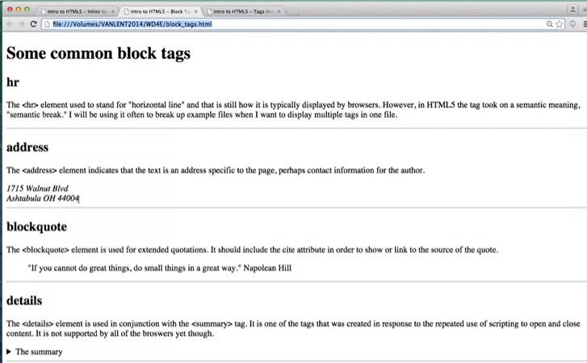

Alright, so there's <hr>, <address>, <blockquote> and <detail>s.

I've told you what they were.

My guess is, you still have no idea what they really do, so

let's take a look at a quick example.

So here would be an example of the hr element.

It's just a simple line across the screen, nothing too fancy, but very recognizable.

The next one, the address element.

In this case, the browser does italicize what's inside the content.

I had to put my own end line here, but

otherwise it just looks kind of italicized.

But you can't be sure that it'll be italicized on every browser.

It's really specific to Chrome, Firefox, Safari et cetera.

But the important thing to know is that there is semantic meaning here.

Here we have a block quote, and what block quote does, is it lets, indents the code

and kind of lets people know that there's a quote that you're look at.

One of the things that I put inside my blockquote, was I put in a cite tag, so

someone can know right away that I cited Napoleon Hill.

So if someone's doing a search for Napoleon Hill,

this is going to up the chances that a search engine will link back to your page.

The last one, detail, is kind of combined with a summary tag.

So I'm going to go ahead and click here and you can see that it opens and closes.

So the default is to have it closed and

then open up when someone clicks on the little arrow icon right here.

Now one of the things I mentioned is that it's not supported on Firefox.

So if you're looking at this page on Firefox,

by default you're just going to see it in the open context.

So let's go ahead and go back to some other tags that aren't block tags.

We're gonna do some inline tags.

Again remember, inline tags just means that you can put it into the page and

go all in a line one after the other.

You don't need to break things up.

So span was the original inline tag for plain text.

You would put span around some code, and then you could go ahead and

style it any way you wanted to.

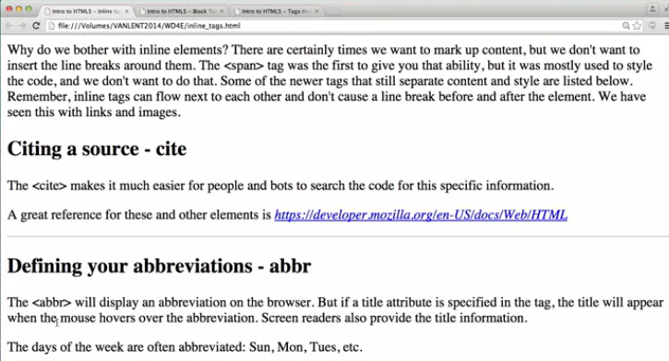

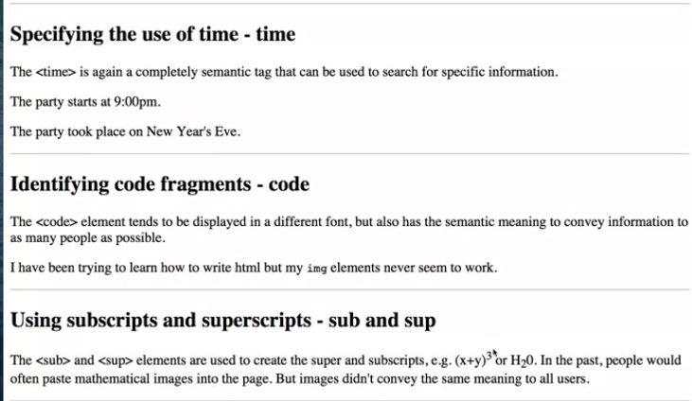

Now, in addition, we have cite, abbreviation, time, code and

then the subscript and the superscript.

Now, if you're watching closely you may have noticed I left a little typo after

abbreviation there.

So make sure you go ahead and put in the less than or greater than sign.

But let's look at examples of this code as well.

Here I have my inline elements.

The site basically makes it easier for people or bots to search your code, so

I went ahead an put this code right inside a site tag.

Now, again, this particular browser happened to style it differently,

but that's not always going to be the case.

Another new tag that has come along recently is the abbreviation tag.

So if you notice, right along here, I've included abbreviation inside the box.

Now, if you can, watch what happens when I put my mouse over the Sunday,

Monday and Tuesday.

As I hover over it, it's very small probably on your screen, but

you can see that the expanded version of the abbreviation pops up, Sunday,

Monday, Tuesday.

Now, from an accessibility screen point, it can actually go ahead and

read the expanded version.

But even for people who aren't using screen meters, I actually find that

you need to do something to let people know that hovering over is even an option.

Most people wouldn't think about that.

The time attribute is another one that is just inline and most of

us won't even know it's there but it allows you to give extra semantic meaning.

So the party starts at 9 PM.

It makes perfect sense to us, but the party took place on New Year's Eve.

Notice again, that's actually a time,

even though it's not our typical numeric time, it is a time.

By putting in different time tags,

it's also much more likely that if someone is accessing your site on a mobile phone,

it'll pop up as knowing that it's an eight.

Sometimes you would like to be able to identify parts of your code as code

fragments.

This happens to me all the time because I'm a computer scientist.

So the code elements tend to be displayed in different font but

it's not always the case.

But code is just a nice way to break it up and

let people know what is this crazy stuff people are typing?

Oh, it's code.

It's not supposed to make sense.

Finally, the last two are subscript and

superscript, and these are used to create, a lot of times, mathematical formulas.

So, you can see here, I've raised up the three, and I've lowered down the two.

So, I've given you kind of the general block tags,

the general in-line tags that people use.

And there's other tags that people use quite often

that you may see when you're looking at their pages.

The issue with these tags is the thing when I say need more.

It's really weird to use these tags unless you're also incorporating them with

JavaScript or some other elements that you probably don't know a lot with yet.

So these include the button, the <meter>, <progress>, <iframe>,

<bdo>, which stands for bidirectional orientation, and

then the <map> attribute along with <area>.

Now, people really like these, but they tend to need JavaScript.

So I'm gonna show you a quick example.

But I'm not going to include the fancy addons you would need to use then.

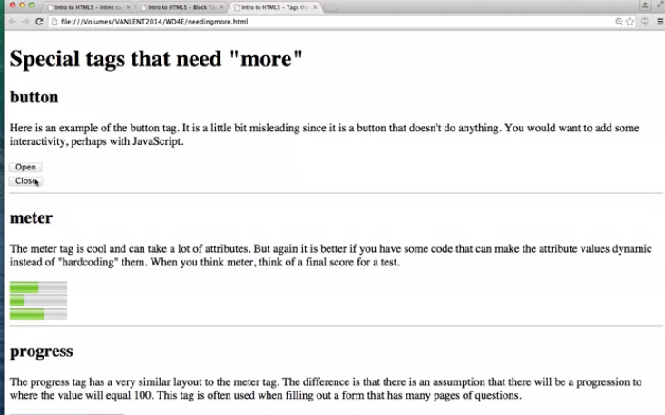

Cuz that's not what this course is about.

Right now, we're just learning these tags.

So let's take a look at them so you can see what they look like visually and

understand that there not actually functioning yet.

So, my special tags that need more, I called it.

Little word that you might not even be able to see it because it's so

light in screen but you can see I've included some open and close buttons.

They don't do anything but they look really nice.

So go ahead and put them in if you want but

it may confuse people that there not actually operational.

The next one is meter, and you've probably seen this before.

Basically how this one works, let me actually bring up the code for this one.

You can see for the meter one I've actually gone in here and put in meter

minimum value of zero, maximum value of 100 and my current value is 50.

So you can see it's colored in until about pretty much half way through all right?

Same here with the next one, I've set it to 25% Here I just want to

show you that it doesn't always have to be 0 to 100.

You can start at 5 and go to 10, and I've set it to 8, which is 60%.

So that's kind of how the meter works.

Progress is very similar to meter in that it shows kind of a proportional value.

Now, with progress, you're expecting that you're doing something where

eventually you'll get to 100.

So you've taken the surveys before where as you filled in,

the progress bar fills in.

Again both meter in progress tend to use JavaScript to update them.

The next one I was going to show you is iframe.

Iframe is used to nest content in each other.

It is not equal well supported by all the browsers, so

you really want to explore who can use it and the best way to use it.

And you would definitely want look into options, such as height and width.

So right here in my iframe, I've said hey, let's go ahead and link back to my page.

And it puts my whole web page inside this little block of the page.

Down here, I went ahead and said hey, let's do that iframe again, but

this time let's go ahead and have it take up a much bigger width, all right?

Now, one thing to notice is I can still click in here.

I can do all the things.

It's as if I have a webpage inside of a webpage.

The last one.

Let's go down here.

I want to show you is a bidirectional orientation.

And this one would be something you would use if your particular language tends

to not just go from left to right and instead goes right to left.

So bidirectional orientation take either rtl which stands for

right to left or ltr which stands for left to right.

And you can go ahead and put in the text.

So here is my going from left to right and

here's that same thing going right to left.

I didn't really give examples of the map with the area.

Because, again, this is one where you would really need to understand JavaScript

to really embrace what it's doing.

So I realize I went over a lot of tags with you just right now.

And some of the code, you probably understood and some of it, you didn't.

But all of the code is online,

so you can go ahead, you can download it, you can play with it, you can change it.

But as you code, you're not supposed to go in and be like, oh,

I'm going to try to use every possible tag I can to show how much I know about HTML.

No, use the most specific tag possible.

Whenever you're not sure go and ask somebody else say what would happen if I'd

trying to look at this page with my eyes closed, what I understand what's going on.

The second thing you need to understand is that sometimes your tags just don't work.

Now, there are two reasons that your tags may or may not work.

The first one might just be that you have a syntax error.

So, make sure you run your code through a validator, and

that will help you find places where you haven't closed tags.

This is especially important if you nest tags,

meaning you put one inside the other.

The other thing you really want to do,

is you want to run your code in multiple browsers.

So, even if your page looks great when you're running it in Chrome,

make sure you check it out on Firefox.

If it looks great on Safari, make sure you check it on Chrome.

It's really important that you make sure that your pages

can be reachable to the greatest number of people possible.

And really, the only way you can do this is by keeping your code simple,

succinct, and you're always validating.

Thanks.

One of the things that I'm constantly talking about in my courses is

accessibility.

The things is that I've come to realize is that I can talk about this as

much as I want but it's really up to me to show to you why it's so important for

you to make the Web as accessible as possible for others.

So today we're going to talk about three things.

First, I would like to explain what a Web accessibility professional does.

Second, we're going to talk in-depth about how disabilities relate to the Web.

Finally, I am going to introduce for

the first time the four principles of accessible interface design.

These four principles are something that will hopefully guide you

throughout the entire time you're making Web pages.

So let's start off with this whole idea of what a Web accessibility coordinator does.

One of my pet peeves is people who say they don't wanna go into technology

because they'd rather do something where they can help people.

Well, my follow-through to that is that, if you really want to help people,

you need to understand technology.

So, one of the things that people like to do is find careers where they can help

people who have issues, and work together with people who are in technology.

And that's exactly the type of thing a Web accessibility coordinator will do.

So first, one thing they might do is help guide policy and purchasing decisions,

on what kind of software is most accessible to the widest range of people.

Second, they can evaluate Web interfaces for accessibility.

So by learning just some key tips and tricks they can go to different pages and

find out where there might be pitfalls for people.

Third, they can assist people with disabilities to access

online infrastructure.

Most universities and large companies will always have someone

who's job it is to assist those who need some help accessing online material.

Or really, any type of technological tools.

Fourth, it's very important that people keep pace with changing technology.

You will always have a job if you can find a way to combine your love with helping

people with the different tools that are being used.

So, let's talk specifics.

According to the 2012 U.S. Census, 1 in 5 people in the U.S. have a disability.

That means that there are 60 million people in the U.S.

who are dealing with issues that other people may not have.

And half of them are impeded from using the Internet.

So we will talk briefly about four issues that tend to pop up the most

when dealing with disabilities and the Internet.

Visual issues, hearing, motor and cognitive.

When you talk about accessibility almost everyone thinks about screen readers.

They design and

say, oh I'm gonna make sure that my page will read well on a screen reader.

However, it's much much more than that.

While 1.8 million people are completely blind, we also have 8 million people who

have difficulty reading ordinary newsprint even with their glasses on.

So one of the things that we want to think about when we're designing

is more than just font size, we also need to think about color contrast.

Your different font style.

Can someone really see your page as easily as possible?

We also want to think about hearing disabilities.

We're talking about from partial to total deafness.

So 8 million people have difficulty hearing in normal conversation and

1 million are completely deaf.

More and more places are moving to online presence and

of course we all know that watching videos online is a very common thing.

We're all doing it right now.

So one of the things to think about if you decide to add videos to your

site is did you include the close captioning

to really make sure as many people as possible can access your content.

But there's also other things to think about.

Are you blaring music?

You might have users who don't even realize that music is playing.

Or perhaps you have things so

low that people can't quite grasp what you're saying.

One of the things we're gonna talk about is making sure that people have

the ability to control the different multimedia that you're gonna put on

your page.

This is going to help people with hearing disabilities feel that they are in command

of the technology, not that the technology's in command of them.

One of my own personal issues is that of motor disabilities.

There are many, many people who are unable to use a mouse or a physical keyboard.

Maybe they have slow response time or just limited fine motor skills.

So dexterity issues are something that affects 8 million people who have

difficulty using their arms or hands.

But my guess is that for most of us have had some issue with trying to use the Web,

and haven't been quite able to do what we hope to do.

So one issue that we talked about is what happens when someone tries to

tab through your page.

This is a very common way for people to get through pages.

But unless you're very careful you can make it that people tab through

to nowhere.

Another issue is do you require a steady hand?

Many people like to add flashy and cool graphics and animations to the their page.

But I know that I personally have been frustrated at trying to click a button

while the button keeps moving around the screen.

Another issue is cognitive disabilities and when we talk about cognitive

disabilities, there's a very wide range of issues we might be talking about.

There's learning disabilities, distractibility, dyslexia.

Even the ability to remember or focus on large amounts of information.

Some of the things I was laughing at when I looked at this slide just now is that

this slide, perhaps, has too much text on it for

people to really be able to focus on what I'm looking at.

So, we're saying that there are 16 million adults with ADD or ADHD.

Another overlooked population is that there are a large number of soldiers,

Marines, and National Guard members who have different psychological conditions

such as traumatic brain injury, or post-traumatic stress disorder.

Now what does that have to do with making your Web accessible?

We wanna make sure that things are easy to understand,

not flashing, not requiring great amounts of concentration.

Cognitive disabilities number greater than physical and

perceptual disabilities combined.

So it's something that you want to think about when you're designing your page, or

even if you're just help other people design theirs.

So let's get the specific stats because nothing helps me convince people more that

they want to design for the Web than showing them the numbers.

So almost 10% of the U.S. population has two or more disabilities.

40 thousand people in the U.S. are both deaf and blind.

So think about trying to access technology when you have those types of issues.

41% of adults 65 and older have a disability.

And there are almost 9 million people with disabilities who are poor.

70% of the disabled are underemployed or unemployed.

The issue is not that they are not able to do the jobs that are out there.

Many times there are roadblocks put up there that they can't get through

in order to do jobs that they are very well qualified for.

So the Web offers unprecedented opportunities for the disabled.

Here we are right now all taking a class online.

So education has the benefit in that we teachers can reach as

many people as we can.

And for students,

it means that you have access to resources that you never had before.

Many, many people get their news from online resources so

we wanna make sure that we make it available to everybody.

Commerce I find particularly interesting

because many many places have online presences but

are even realizing that they're alienating such a large customer base?

And of course the social benefits of the Web are easy to see, so many

people have created more friends online than they actually have in real life.

So the benefits of the Web are amplified for the disabled.

People who before could not access education, news, commerce or

social interaction, are now able to do that.

So the Web is an enabling technology and

we want to make sure that we continue to make it so.

So hopefully I convinced you just from a human standpoint that it's important

to make your Web pages accessible, but there are of course legal aspects as well.

The Department of Justice is in the process of updating the American with

Disabilities Act to include online resources of state and local entities.

What this means is that universities, state governments,

local governments all need to make sure that the information they have

online is accessible to everyone.

There are many instances of case law where individuals or

groups have filed civil complaints against universities, companies because they feel

that their products are not accessible to people in a way that it should be.

So, let's just review this for a second.

What is Web accessibility?

What it is is making sure that you're making your Web accessible for the widest

possible audience, this includes people with permanent disabilities and

those with temporary disabilities.

Currently, the online infrastructure,

while a wonderful resource, is hostile to those with disabilities.

Another issue you want to think about is that accessibility is inseparable

from search engine optimization, mobile technology, and usability.

Improve one of these things and you can improve all the others.

So what's the best way to accomplish accessibility?

It's adherence to standards.

As you start now, you're at the very beginning of your Web career.

It's the perfect time for you to learn the best possible tags and

the best possible ways to make your page accessible.

These standards are going to come from the W3C Web Content Accessibility Guidelines,

called WCAG.

And these guidelines are printable, not technology based.

What this means is that you don't need to go out and find the greatest language or

greatest technology to make your page accessible,

instead you really just need to follow four principles as you design your sites.

Is my site perceivable, is it operable, is it understandable, and is it robust?

We'll be talking about these four principles throughout our entire course.

So, let's review quickly.

I know that right now you're just starting your Web design career,

and it can be overwhelming.

But I'm really hoping that one of the things you'll make sure that you do

is design with accessibility in mind.

It is the right thing to do for so many reasons.

Whether it's because you really want to reach out to the largest customer base you

can, or because legally it's required.

The important thing is make sure you do it.

And the great thing is accessible design is actually pretty straight forward.

All you need to do is adhere to standards.

The reason that many pages are inaccessible,

is because they're trying to be flashy and

cool and do things that aren't quite yet fully implemented to standards.

So, finally as we go through this class make sure that you pay special attention

to the semantics behind HTML tags.

These semantics contain special information

that are going to make it much easier for

people who are using assistive devices to understand the content of your page.

Together we can make sure that the next generation of Web developers

are designing for the greatest possible audience.

Go to <http://wave.webaim.org/> and enter the URL of a website of your choice. Then select the "No Styles" option. How much harder is it to perceive the contents of the page when you just have the HTML?

Go to one of the websites you frequent often. Hit the tab button to see how you would navigate through the page. Is it easy to get to the information you want?

# **Does your browser support accessibility?**

In the Week One material you may or may not have run the test at <https://html5test.com/> to see how well your browser supports HTML5. But you should also find out if that HTML5 is easily usable by people who rely on assistive technology without having to use special work arounds. The site <http://html5accessibility.com/> tests which HTML5 features are accessibly supported by major browsers. This includes if they are keyboard accessible and if any accessibility related features are supported.

Hi.

Today we're gonna talk about the very important,

but often overlooked process of validating your site.

What I mean by that is it's time for us to check your code.

So why do we wanna validate?

I like to call browsers the helicopter parents of programming.

So a lot of times you're gonna be writing up your code and then you'll stop and

you'll check and it looks great.

And then you write some more code and you stop and you check.

And it looks great.

And by the sheer fact that it looks so good, you assume you must be right.

But the p problem is, browsers are programmed to kind of look for

your errors and fix them.

The problem with this is that, not all browsers fix things the same way.

It's also important to remember that not everyone is accessing your

page with traditional browsers.

So as your page becomes more complex, these little hidden problems,

those little hidden errors that the browsers are hiding, can become

devastating to people who are trying to access them with different software.

So there are 3 approaches for validating your code for consistency.

One is to validate what we call the URI or the URL.

Another is to validate by your file name which means instead of giving you're URL

you can actually upload your file to check it.

The third way is what I called by Direct Input.

So, let's go ahead and run through an example very quickly.

In this side I'm gonna use is called the validator.

All right.

So, if you check here, we can start off by going to the validator.w3.org.

As you can remember, the w3 is really the association for

trying to make sure that everyone sticks to the same standards.

And here are three options.

We can validate by URI, the validate by file upload, and

the validate by direct input.

Now this is a somewhat important choice.

Because for some of you, you may not decide to buy a hosting system,

in which case you can not give it a URL.

You can't type in C:// it

just doesn't work when you put anything that's specific to your computer.

So instead I'm going to show you an example of validate by direct input.

So let's start by looking at the page we're gonna validate.

Over here I have my little picture of Ashtabula with the beach.

And as you can see, it looks pretty good,

you don't see any problems with it as you kind of go back and forth.

But let's see what happened when I actually grab all this code.

So if you want this shortcut, this works for almost everyone.

I'm gonna go ahead and do control-A and control-C.

Head back over here and when I put it in and

I click on check, once I start going down you can see this looks good.

Right away it says you have an error and that error says stray end tag, and

that's for a section.

In most cases, the validators can kind of give you a clue

as to which line you've messed up on, so let's go back and check the code.

When I go over here and I go down to line 25.

Oops.

Go up a little bit here.

Nope, still nothing there.

Got really long lines.

Oh, the validator's right.

As you can see, I accidentally put section twice.

What I really meant was to have an end section here and a beginning section here.

So let's go ahead and get rid of that.

I will save, I will grab it all again and let's try above putting in a new input.

I'm actually gonna refresh.

Go back here.

And let's see if I have better luck this time.

Good, good.

No errors or warning to show, so I'm just going to go ahead and

put my page back out there.

So this is really just the simplest way to go in and

make sure the syntax of your code is correct.

Now, I kinda gave you a really simple example where I only had one error.

What typically is going to happen is that it's gonna generate lots and

lots of errors.

And what I want to happen is make sure that you don't freak out when you see all

of them.

The reason is, is because error is what we call as propagate.

The checker gets confused.

When you see one error at the top, it kind of leads to a whole bunch of errors.

So what you wanna do,

is you always wanna fix the first error that the validator saw.

Once you fix that, there's a really good chance

that the 52 errors it detected have now dropped down to 12 or 11.

Now, there's also the chance that once you fix one error,

it's gonna be able to see that you had 20 or 30 more.

But again, work on it step by step.

If the error that the validator gives you isn't as clear as the one that I just saw,

what you can do is search online and in the different forums.

Because I can assure you that other people have seen the same errors before.

So what you want to do right now, actually let's go back here, is let's go ahead and

try validate file by URI.

Pick your favorite site and go ahead and type it in.

I'm going to go ahead and put in, not my own because I'm pretty sure it validates.

I'm going to put in http://www.umsi.umich.edu, so

my boss can get mad at me when I show his site potentially doesn't validate.

Right away you can see that' it's going to find a lot of errors.

No matter what site you put in, particularly if it's a very popular site,

you're gonna see that there are a lot of errors in that big,

the sites don't validate.

Let's make sure your sites are better than theirs.

So it's one thing to validate for what we call syntax.

It's another question to validate for what we call accessibility.

Again, we've talked about how important it is to make sure that

your sites are accessible to the greatest number of people.

So one of the places you can go to check that is wave.webaim.org, and

it's a site for you to go and validate you accessibility.

So let's take a look at that one again.

I go up here, and I go to wave, got web accessibility.

What you need to do here is, you can't upload your code by file,

or just by the code itself, you need to put in a URL.

So i'm gonna go ahead and go to that same one we did before which

was the beaches.

And put it in here.

And you can see I didn't get any errors, but I did get a couple of alerts.

And the alerts were simply telling me that.

I'm not sure if your alternative text is quite as good as it should be.

And also, another point is saying you have the same, a redundant link,

which means you have the same link twice.

So, right now everything looks good as far as syntax and

the very high level of accessibility for the semantics.

So, one of the nice things about the accessibility validation is that it

gives you an idea of things that you haven't really thought about before but

the downfall is that it only works on hosted pages.

So validated sites are always more robust and

more accessible than those sites that don't validate.

So, as a coder it is your job to make sure that you go to these

different validation sites and fix your code to be up to standards.

If you're not coding it is also important for you to visit the sites

that you go to on a regular basis and go ahead and validate those.

Giving you a real sense of the different ways, people feel the importance or

not importance of making their site accessible to everybody.

Good luck.

One of the things I'm really hoping that students will do is validate their code.

You can validate it for syntax,

but you can also validate it for accessibility.

So, today I'm going to show you how I use the WAVE Tool to test different sites.

I went in and I check to find some of the top 10 visited sites for 2018,

and I found Google,

Wikipedia, Reddit, Yahoo and, Amazon.

So, let's just do a little investigation to

how well each of these sites addresses accessibility.

There's two ways to test.

One is to actually go to the Wave site, which is wave.webaim.org.

From this site, you can actually copy and paste the address of any page you want to test,

and this is a great way to do it.

Personally, what I did is I went ahead and added the wave extension to my page.

So, if you look right here,

it's possible if you own your computer to download

an extension that looks just like this over here,

this little tiny W, and it makes my life a little bit easier,

because it lets me actually just click on this button rather than going to the Wave site.

So, let's go ahead and check out some of these sites.

I'm going to start with Google.

I'm at Google, I'll click the "Wave validator",

and it's going to go through and check for any errors that might see,

and in this case, we have two errors.

In both cases, the errors are that we have empty links.

Somewhere on this page,

there are links that don't really link to anything.

Now, I'm trying to find them and you can't see them on here,

but that's because Wave checks for all the different variations of your page.

So, while it might look good on the desktop,

it doesn't always look good on say,

your phone or a mobile tablet.

Google did pretty well.

Let's go ahead and check out Wikipedia.

Here on Wikipedia, I'm going to wave it.

Sometimes, it takes a second,

I always forget and I need to be really patient,

because if you click on it and then you click on it again too quickly,

that's how you turn it on and off.

So, I clicked on wave,

I'm going to wait for the few more seconds,

and you can see that once again, Wikipedia,

like Google, did a pretty good job of addressing accessibility.

They have one empty button and what they call missing form labels.

What that means is down here,

there's some place they would like us to type something in.

But, someone who is vision impaired might

not know exactly what is it you want me to type in?

So, both these little buttons right here say, "You know what?

It would be a really good idea if you would add a form label,

so somebody knows what it is they're typing in."

The form label here might be search query,

and the form label on this blue button might be hit me to perform search.

Still, three is really good.

So, let's go to Reddit.

Reddit is a very popular site,

a lot of people use it to feel better about themselves,

because they think who would ask that question,

and other people go here for real reasons to find out an information.

It's such a popular site.

I'm really hoping it'll be accessible.

But according to Wave on their last rendition Reddit had, let's take a look.

All right, and from here we can see that Reddit has 73 errors.

Not surprisingly, because there's so much user-driven content.

There's a lot of people uploading pictures or typing things in,

and they don't know about accessibility.

They don't know about things like, "Wow,

I should really be adding my alt text to these different images."

Otherwise it's going to be hard for people to access them.

Or you can look down here.

In fact, that's exactly what it is.

It's missing alternative text here.

Oops, missing alternative text here and missing alternative text.

Lots and lots of missing alternative text.

The another thing that Wave really tries to get people to avoid

doing is having empty links.

This idea of links that you don't know where they're going,

and they also really don't like redundant links.

Just makes it hard for people who are using the computer via keyboard to

have to click so many times to just get to the same information over and over again.

So, unfortunately, Reddit not great for accessibility,

but really good for my example here in this video on checking your pages.

The next one I'm going to do is,

just said Yahoo in general.

So, I picked a Yahoo Sports.

We can take a look and see how this sport side is going.

Now, unlike Reddit, this is

professionally commercial software system

where it's people who are being paid to upload the content.

So, we'll hope that there's a little bit more accessibility here.

So, here on Yahoo Sports,

you can see that I've got 44 errors.

So, that's just take a look at what general things they're missing.

Well, it's alternative text,

which is funny if you look at it,

you can see that they're saying, "Ooh,

lots of places you're missing alternative text,

and that must mean right here each one of these little scores is not text,

it's actually an image."

This gets people into a lot of trouble.

Sometimes, you want to put an image up on the screen and it's really not decorative,

it's telling a complete story,

and in that case, alternative text is so important.

Otherwise, people with vision impairment may

not be able to see what the score is for the various games.

All right, the last one I'm going to do is Amazon,

and I think I'll do that one straight from the WAVE Tool.

So, I go here, I typed in Amazon.com,

and Amazon is not doing too badly.

You can see they have the same problems that most people do.

It always comes down to this missing alternative text, right there.

There's a few reasons for this.

On some sites, the public is uploading the pictures,

and they don't know about alternative texting,

so we have to educate them about it.

Sometimes, it's because we've written programs to update the sites,

and unfortunately, computers aren't very good at

knowing what alternative texts they should add to pictures.

Unfortunately, it's also because some people do know and they just don't really care,

think it's that important.

So, as much as possible,

I want you to add syntactic and semantic clues to all your code.

Make sure people who are looking at it or

listening to it have the greatest possible experience.

One of the other accessibility tools that I've recently come across is called Funkify.

Funkify is another extension that you add onto

your browser to let you experience visiting pages in a whole different light.

So, here I am back at wikipedia.org.

Earlier in another class,

I showed that putting it through the wave validator shows that Wikipedia

has really done a pretty good job of making sure their site is accessible.

So, let's try the Funkify tool.

How Funkify works is it let you take on different

persona's to try to see what the site would look like for different people.

So, for instance, if I were to turn on Blurry Bianca,

you basically get to experiences page as if you had blurry vision.

You can even change the intensity of like the blurriness,

if that's a word, to have it go from pretty low to pretty high.

There's dyslexia, which I think is personally quite interesting

because I know so many kids who struggle with, and adults,

who struggle with the idea that on a webpage,

oftentimes things are moving around much more quickly,

the videos and the pictures.

But not just that, the text has a wave from moving around with them.

You can't solve that problem,

but what you can do is make sure that you're using large enough font,

so that if things do move around,

it's not too disorienting.

You can always also makes sure that you're

spelling and grammar is correct, that will help as well.

All right. The next one is Trembling Trevor.

This one's quite common for people who maybe have a little bit of trouble

with a mouse or with the keyboard or different things that need a lot of dexterity.

So, I'm going to click on this one,

and then I'm going to click over here, if I can.

You can see with Trembling Trevor,

as I'm trying to move the mouse around,

it doesn't move very easily for me.

It kind of jumps and goes.

I fall victim to this a lot of times myself when people have very tiny buttons to push.

So, I'm going to turn off Trembling Trevor here.

You can add, increase or decrease the amount of trembling.

Tunnel Toby, this is the idea that some people actually,

their partial vision loss would look something like this.

So, this is pretty high amount of vision loss.

You can change it and get this idea of what people are seeing.

They might only be seeing a very small amount of your screen.

Peripheral vision, is this idea that sometimes people have this one spot that's blocked.

So again, you can't fix this issue for people,

but you can think about your page and you can say, "Hey,

is there something on my page that's really important,

just so important and it only appears in one spot?

Do I want to put it in more?"

Color Carl is pretty common.

This is just the idea that,

how does your page look if we were to get rid of all the colors?

Are you using color?

Let's go and do this one.

So, this is Greyscale.

I'm going to click in here.

You can also look at green.

It take away a lot of the green.

You've got the red and green,

the blue and yellow.

They include some statistics that basically 1 in 1,000 people have trouble with

this color combination or 1 in 100 men or 1 in 300 women have problem with the red green.

So, testing your site to make sure that color isn't conveying something important.

Then, they also included some or it's

a combination of lowered vision and trembling hands.

The last one I like right here is the Sunshine Sue.

This is accessibility, kind of even more for the accessibility

for everyone because so many people take their devices outside.

You can say, "Oh,

hey, if it's really bright outside,

are people can be able to see what's on my screen or should

I be changing some of my color combinations and contrast?"

So, Funkify is, I mean I hate to say it's a fun little tool

because there's nothing funny about people not being able to access your page.

But they did do a good job of trying to explain how

these different types of abilities can come

in and affect the way that people interact with your page.

So, if you're interested in accessibility and you want to go

a step further to make sure your page is something that everyone can enjoy,

I highly recommend you installing Funkify.

# **Putting Your Code Out on to the Web**

The videos in this next section are intended for those students who want to post their websites to the Web. Until now you have been viewing your files **locally**. This means that the browser isn't sending a Request to a server, but rather just retrieving a file from your computer. (This is why the protocol in the address bar is **file**, not **http**.) So go ahead and watch the "Hosting Your Files" video but feel free to skip the lectures on cPanel and SFTP if you don't plan on hosting your files on the web. You can always change your mind and host them later.

Hi everybody.

Today we're going to talk about hosting your site.

And what I mean by hosting your site is how you take pages that you've been

working on so far and put them up on the Internet for everyone else to see them.

In order to host your site, you need two things.

You need, first, a domain name.

That's the name that people look at in your URL.

The second thing you need is a hosting company, usually called a hosting service.

And they are gonna be the one to act as a server for

your files to let other people see them.

So first, let's talk about domain names.

Usually, when you go to buy a domain name, you're gonna purchase it for

multiple years at a time.

Cuz it really doesn't make that much sense to own your domain name for

only a single year, unless of course maybe you're running for an election or

doing something where you know you only want it up for a short time.

The most common domain names have the domain ending of .com.

But more and more the other extensions are getting acceptance.

So if you're go to buy a domain name, and the only way you can get the name

you really want is to use .net or .biz, that's okay.

I recommend that you still go ahead and do it.

The important thing to know is that domain names by themselves,

they're really pretty much completely useless.

You can own it, but unless you have files there that people can look at,

no-one's going to be able to go there and see anything.

So this is where the hosting services come in.

So if you were to look at your url right now on your page, when you make a file and

you right-click and you're looking at your site, in Chrome or Internet Explorer or

anything like that, you're probably gonna notice that the protocol is file.

We don't want that. We don't want it to be file or C: or

my documents.

We want it to be something that looks like www, and

that's where the hosting company comes in.

So, what you need is a registered IP address to connect your domain name

with the Internet.

So, hosting services are going to vary.

They go from free, to what I call midrange, to really full service.

And so, you need to decide what kind of hosting service best fits you.

To be honest, I usually recommend free when you're getting started, and

then make your way up.

But let's talk about the pros and cons of each one.

So with free services, you really have little or

no control over your domain name.

So if you go and look at some other people's, particularly from your school,

your work, things where people are not really there just for the domain name,

and you're gonna see things like wicks.whatever.whatever and

then your name.

You're going to have really limited tools.

Sometimes when you pay for a site, you're gonna be able to have

email registration and different things like that.

Free services don't really wanna give you too much freedom

because they're a little worried about what you're gonna do.

Probably the worst part about free services is that there's a lot

of advertising and redirects.

If somebody goes to your site and

makes the smallest little typo, rather than getting a nice friendly warning,

they're probably going to be redirected to some somebody trying to sell something.

The nice part about free services is that they have a very familiar look and

feel across all of them.

If you sign up for one service and

learn how to do your hosting on it, you can pretty much rest assured that you're

gonna be able to manipulate your files on any other free service as well.

So let's talk about paid services, both the mid range and the full.

With paid services, you tend to have much better tools for manipulating your code.

It's not just about putting your files up on the web.

You can do things like have email filters, send out special, what we call cron jobs.

Cron jobs are different files that you can run at different times of the day.

So if you wanna have a database, you wanna have a list server,

you wanna have emails, then you might wanna pay for the paid services.

The other really nice thing about paid services is that there's technical support

available to you.

So you can go ahead and email, chat, anything you need.

You're not gonna find that with the free services, or

it just won't be quite as good.

But before you go for the paid services, I really recommend that you check for

free services through work or school as well.

A lot of time these free services still have the really great tools and

the support, but you just don't have to pay for them.

So, if in the end you're not quite sure what you want to do,

if you want to go with free or

paid, I know it can be overwhelming when you decide what you're gonna do.

So I've simply recommended one site that I know a lot of my students use and

that's Byethost.

You go ahead and go to this url, byethost.com.

Notice that it's b e y t h o s t .com.

Once you get signed up, you're going to want to make sure that you remember

the password that you type in because they're not going to mail it back

to you and if you cannot remember it, it's really going to lead to a lot of problems.

In fact, you'll probably end up giving up and signing up for a new account.

Once you've done that and you've filled it out,

you're probably gonna need to check your spam because in that spam,

they're gonna send you an email that tells you all the details that you're gonna need

in order to connect through either cPanel or some other type of FTP device.

So, I hope you're excited, and I hope you're gonna take that next step, and

that you want to go and post your work out on the web.

Good luck.

Hi, this video is gonna be a quick tutorial on the cPanel interface for

managing your site.

Let's go ahead and say that you've gotten a job or you have a homework assignment,

and someone says, hey.

I want you to go ahead and put your site up on the web.

Many people's first reaction is, great, how do I do that?

So, one of the most common ways is to use the CPanel interface.

In order to use it, what you need to do is have the URL for your cPanel account, or

your web hosting account.

So if you have a domain name, such as introwebdesign.com or

yourname.com, when you created your account, and you got your domain name and

hosting service, they should've sent you an email that says what your URL is.

So usually your domain name followed by slash cPanel is where you need to go.

Once you go there, you come to a nice login where you can access your different

files, and I'm gonna show you in real time in just a few minutes.

So, what a file manager does is that it's a way for

you to upload or download your files.

This means you take them from your computer and you put them up onto the web.

So, regardless of the kind of CPL configuration you have, one of the first

things you wanna learn how to do is figure out how to find the File Manager.

From the File Manager, you're going to look for a special folder called

public_html, or in some cases just public, or they may have dropped the html.

But the important thing is that you want to find the word public.

Your public_html folder is going to have a lot of different files,

some that you want people to see, and some that you don't.

I mean, if you think about it, when you go to Amazon or other different sites,

there are certain pages they want you to be able to access, but there are many more

important, confidential files that you should not be able to get to.

So uploading files to your public HTML folder makes them viewable to the public.

So let's say that we're at my website, and I decide I wanna upload a new file.

In fact, here's a file right here.

It's a pretty simple one, it's not even a full file, and

it is just a file with two images of my dog.

Okay, so I would go here, and I would go to my URL, and I would add on cPanel.

What should pop up from here, is a username and place for

me to enter my password.

Now if you're not sure what your username and password are,

just make sure to go back to the email that your hosting service sent to you.

They'll tell you what it is.

So once I log in,

you tend to have a fairly familiar site set up when you're using cPanel.

Now, different cPanel accounts are gonna have different software that you can use,

but the one thing that they will all have is something called the File Manager.

So head down here, and I find the File Manager.

There's gonna be lots of different options.

I usually just go with the default or find where it says public _html.

All right, so when I login, everyone's is going to look different

because it depends on what files you've already uploaded.

For many of you, the first time you go in, you will only see the cgi-bin folder.

Go ahead and leave that alone.

So I wanna upload my file over here.

So I'm gonna go ahead and go to Upload > Choose File, and

I am going to pick, oops, it's right up here.

Safari images, short.html.

Here we go.

All right, as you can see down in the corner,

it's showing that it should be uploading correctly.

So go over here, and I want to check and make sure it there.

Oh, it didn't work, and now we wanna think about why that didn't work.

Okay, so I have here some issues that may have gone on

along with the one I already showed you, and that is wait, why can't I see my file?

Well, there are three main reasons.

The first might be that you typed in the wrong URL.

So, go back and check that out again.

Did I make sure to type in the right file name?

Maybe I forgot I had an s or something else down there.

Second, when you uploaded the file, the transfer didn't work.

So many times when you're uploading,

you wanna make sure that there weren't any error messages on the cPanel.

The final one, which we'll show you right here,

is that when you uploaded the file, you did not have what we call read access, and

this happens a lot when you're dealing with images.

What this means is that your computer said, oh,

sure, I'll put this file on your site, but I'm not gonna let anybody else see it.

So, what we need to do, is we need to go in and we need to change the permissions

for that image, and I can show you how to do it right now.

So, one of the things that I wanna do is I wanna look at the code that was

uploaded to the server.

So, I'm gonna go ahead and do, I did a right a click, and

now I'm gonna do View Page Source.

And you can see that it says the pictures that it's looking for

are both called bacon and they're inside an images folder.

Oh, well, that's where my first mistake was.

Let's go back over here, and you can see, oh, great.

I'm gonna reload it.

Here's that HTML file uploaded.

I completely forgot to upload the images that go with the HTML file.

So I'm gonna go ahead and create a new folder.

Call it images, and I'm gonna upload it.

And from there, I am going to upload the picture.

Great.

So let's go over and check and see how we're going.

Oops, that's not the right one.

I'm going to refresh it.

Oh, great.

Look, it worked for one of my files, but not the other.

So let's look at that source code one more time.

And you can see that I put in an intentional mistake.

When you're working locally, when you're creating files on your C drive or

your desktop, your browser's very nice.

It's kind of like the helicopter parenting of browsers.

And it'll say, oh, I know what she meant.

So here, I put the wrong file extension, I used capital J-P-G,

instead of lower cased.

So, while it was great for then, that's not so great now.

So what I wanna do, is I wanna go back over here, go up one folder.

I'm going to what we call work on this here, Code Editor.

And I'm going to change this to jpg.

Let's see how it goes.

Great, now our pictures are working.

So, what you may notice is that I went in, and

I changed my file as it was on the server.

There are two different ways to change your files.

One, is you can edit your files via cPanel, but I don't normally do that.

Instead, what I like to do is I like to work locally,

which means I only change my files when they're on my laptop or my desktop.

The reason that I don't like to make changes on cPanel is that,

first of all, the changes are immediately public.

So if you put in a typo or something you didn't mean to have, it's out there, and

you can't really fix it.

Secondly, there's less opportunity to test and debug.

So sometimes during my lectures I may show you that I'm working on files on cPanel,

but I really avoid doing that.

So at some point you are more than likely to be using

cPanel to upload files to your server.

Different version of cPanels are gonna offer different tools

depending on if you're using a paid or a free site even among paid sites,

there are many different variations.

One of the things that you should do if you're interested in becoming more of

an administrator is look into the different administrative tools

that CPanel often offers.

There are emails accounts, database management and cron jobs.

Cron jobs are one of my favorite, because I teach all my freshman how to have their

email automatically sent to their mothers at 9 AM saying they're studying hard.

An alternative to using cPanel is to use something such as SFTP to transfer files,

or other file transfer protocols.

But the important thing to do is to learn that when you're using cPanel,

you're going to make little mistakes and little things aren't going to work.

The important thing to do is to relax, go in and follow the three steps I mentioned.

Make sure you uploaded the file.

Make sure you don't have any typos.

And make sure that you have the permission set to the way they need to be.

If you do that, you should be fine.

One way that you can share your webpage with everyone is by hosting it on GitHub.

So, the first step is making a GitHub Pages account.

So, I'm gonna go in here and pick a username.

As I type in, it's going to let me know if somebody already has that one or not.

So, here we go.

I've created web designer for everyone.

Make sure that whatever username you pick,

makes sense because this is going to be part of the URL for your site.

So, pick something simple.

Not a lot of upper or lowercase and something that

really kind of describes why you're building your site.

Go ahead and put in

an email, and a password.

Once you've logged in,

what you want to do is you want to create your account.

So, when you click on create an account,

what's going to happen is that they're going to send you or first,

you have to decide what kind of plan you want.

We're going to go with the free plan.

We don't need anything special,

and you don't really need to probably get updates from GitHub news or anything like that.

We're just going to hit Continue.

All right. Again, no need to share any type of special information about yourself.

I'm just going go ahead and click on, well,

Skip This Step I guess because I didn't add anything and now,

we can go ahead and get started.

The first thing we need to do is we need to create something called a repository,

and a repository is a place where you put your code on the web.

Think of it like making a folder on your desktop.

Maybe you've made a folder called HTML where you've been putting all your files,

this is the name of the folder that we're going to put up on the web.

So, this is very important that you follow the rules very exactly.

The first thing I'm going to do is I'm going to go up to the very top corner,

and you'll see a plus.

When you click on the plus, there's something that says,

"New Repository," and this

is a point where it's going to stop and ask you to verify your email address.

I'm go ahead and do that now.

Once you verify your email,

it should bring you back to this page.

So, I'm going to try clicking on the plus again and saying New Repository. All right.

This is where it's very important.

This repository name has to be the same as your account name.

So, in my case, it's webdesigner4everyone.github.io.

In my description, I can go ahead and put something like the website

for web design for everyone.

The second thing you really want to make sure you

do is click on this little button down here that says,

"Initialize this repository with the README".

That's it. I'm going to click "Create," and it takes sometimes a few seconds.

Just to make me everyone can see that Read Me that I clicked on that I created,

it automatically generate a site called web design or for everyone.github.io.

I messed up. I need to rename this because it was supposed to be Web.

Oh actually, I was wrong.

It is web designer for everyone.

I typed my account name wrong.

We're all good. As long as this part right here,

it has to match the name of your account up here. All right.

So now, it's time to check to see if I've made a live website for everyone to see.

So, I'm going to copy this link right here; webdesigner4everyone.github.io.

I'm going to copy it,

and I am going to see what happens if we go here.

Look, I actually have a website that's live to everyone.

I didn't have to pay for anything.

I didn't have to sign up for anything and GitHub Pages is

generally accepted by everyone as a fairly secure place to put your code.

Now, I haven't put any real code yet.

I'm going to cover that in

a separate video because I want to keep the two ideas separate;

creating your GitHub account which you only have to do once,

and then uploading your code to GitHub which you'll have to do multiple times.

Now, just a few notes.

Take a few seconds between each step that I covered here.

GitHub can get very busy and sometimes it might take a few minutes

for something to happen between you cooking okay or accept or upload.

But hopefully, from here,

you won't have too much problems.

In the readings, I'll includes links to other places

you can look for help in creating your GitHub pages account.

So, let's say you've come up with a pretty nice site.

I've got one right here.

I'm going to click on my index.html file,

and I've got some images in it.

I have a special file called CSS that

you might not be familiar with yet, but that's okay.

But let's just see what my site looks like.

Here we go, up.

Here is just a little page I made about me with a little bit of formatting.

But if you check and you kind of look in the upper corner,

you can see that this site is not live.

The fact that it says, file colon,

so forward, I can't share it with other people live.

I can email them my code,

I could say to somebody," Oh look,

I made a web page," and then I could send them

this file and all the images and everything like that,

but that's kind of a pain.

So, let's try to make this site go live on my GitHub Pages account.

So, go back here,

to my GitHub account which if you haven't created yet, that's okay.

I've got another video,

Go create your account and come back here and meet up with us.

But other than that,

I'm going to make my first live account.

Once again, I'm going to go up and do a plus for a new repository.

Basically, consider a new folder full of code.

Last time I needed to be very careful with my repository name, not this time.

I'm just going to call this one,

let's say sample, I try very hard to keep it to all lowercase.

You can include the little like dash,

but no special characters.

So, I'm just going to leave it as sample.

Very important, I'm going to click on," Initialize this repository with a Read Me,

and I click on that,

and I'm going to click on "Create repository."

So, GitHub right now is creating a new site for me to upload my code.

Now, people who use GitHub for,

I'm going to say like real,

are actually doing a lot of things from

command lines and they have to memorize a lot of stuff.

We're not doing that.

We're just using GitHub Pages to host our code.

So, let's click on "Upload files."

Now, here's a tricky part,

if I were to click on "Choose your files,"

I could do that and I could go through and pick,

well, I need this file and that one,

but it won't let me upload entire folders.

See if I click on CSS and I click on open, it's like, "Oh,

is this the file you want?",

I don't want this, I want everything, not just files.

So, I click on "Add".

What I'm going to do is go over here,

and I'm just going to go back up, one,

and I'm just going to drag this whole folder over all at once,

and this is going to let me upload as many files as I want.

The next mistake I make all the time is that I forget to go

all the way down to the bottom and say," Commit changes".

So, this is the first step out of two steps of making your site go live.

The first step is just to upload your files.

Again, this may take a few minutes to complete.

So, while that's going on,

I'm going to go up, up there and then I'm going up.

So, what I'm going to click on now is,

I'm going to go up and click on "Settings." All right.

Now, what I need to do is I need to say, "Hey,

if somebody wants to see my site,

I don't want them to see my code.

I want them to see my actual page."

So, I'm going to go back down here,

and I'm going to scroll down,

scroll down on this mouse,

and what I'm looking for is a site that says, "GitHub pages."

Go to none and choose master branch and save. All right.

You never really know if it worked or not.

So, I'm going to go back down again,

click over here and go back down,

and if I go down to GitHub pages, it will now tell me,

"Hey, your code is now right here".

So, I'm going to click on this,

and it's not uncommon for to say, hey,

you don't have anything yet or something like that.

So, what I'm going to do is,

I'm going to go back to my code and say, "Okay".

What was the name of that folder I dragged up?

Oh it was sampler,

and what was the name of my file?

Hopefully, it was index.html and it is, great.

I'm going to go right here,

and now when I click,

I got a 404 error.

Don't worry, that's going to happen a lot.

First thing to check is,

did you put in a typo?

Yes I did, I wrote sample instead of sampler.

So, let's put that r in there.

Now, I'm going to hit enter and there's my site. All right.

So, what you can do,

the two steps for creating this GitHub account is to upload

your file and then change that kind of link for GitHub Pages to turn it on.

Once you do that,

you can upload as many things as you want.

I am going to do one more thing with you real quick though.

I'm going to go back to my GitHub account

and I'm going to do this one more time but slightly different.

I want to go to github.com.

I'm going to make one more repository.

I'm going to call this one,

sample two, and this time,

I'm going to forget and I'm not going to click on this Read Me.

We'll click on the repository.

Oh! Well, now there's no place for me to click on that upload files,

and you feel kind of stuck.

If you forget, just scroll right up to the ReadMe link on the page,

and you click on it and I'm actually creates the ReadMe.

It going to go down.

Just so you know, commit new file is

the equivalent of save files for what we do in our desktop.

So now, I can upload files.

I'm going to do it one more time to show you

another probably easier way. I'm going to go back here.

Before I dragged the entire sampler folder,

this time I'm just going to grab here.

They're all uploading.

I'm going to click on "Commit Changes."

While this is happening,

I want you to think," What was that second step?

What was that next step she said I had to do?"

That step is to go into settings and add the GitHub Pages.

So, let's go up to settings.

Up, it's going to, right here.

Scroll down at Master branch and save,

and then since I want to be a little lazy,

I'm just going to scroll down here again,

and be like" Oh great, here's the link to my site".

I'm going to click on it. Again, when you get the 404 error,

there's usually two reasons: either you spelled

something wrong which isn't the case here because we clicked on it,

we didn't type anything in.

Or you need to give GitHub a few more minutes to

upload everything or the third one is sometimes,

I'm not exactly sure why, but sometimes,

GitHub seems almost forget to look for index.html file.

So, I'll hit "Enter," and there we go.

So, GitHub Pages is a great free way for you to host

your code and share it with

everyone who you think will be impressed with your incredible work.

Hi, in today's lecture, we're gonna talk about SFTP which stands for

Secure File Transfer Protocol.

What this is, it's a fast way for

your to move your files that you've been creating out onto the web.

So, secure file transfer is just really a common way of moving files from your

computer off to either someone else's computer, off to your server, or

even up to some other computer that's within your business.

People use the terms FTP and SFTP interchangeably.

What's important for you to know is that the S stands for secure.

So a lot of times, people are going to require that you use the SFTP protocol,

instead of the FTP protocol.

So when I say the word protocol, hopefully in your mind that's causing a little bit

of a flashback into our early lectures when we talked about how browsers interact

with the files that are sent to them.

So with HTTP or HTTPS, your browser knows, oh,

here's a file that she wants me to display.

I should ignore all the tags and go ahead and put up a nice site for them.

In the same way, you may have seen that there is a file protocol,

which works pretty much the same way and says they've been making a web page,

and it has been existing on their computer.

With FTP or SFTP, what is going on is the browser is being told don't display these

files, we actually want you to transfer them from one computer to another.

What's also really nice about most FTP/SFTP software programs is that

they let you drag and drop the files instead of uploading them one at a time.

So, let's say that you're ready to go ahead and do secure file transfer.

There's a few things that you're going to need.

The first is your going to need what we call FTP client.

What this is, is a software the you will use to connect different machines.

If you're using a PC a common software program is WinSCP.

If you're using a Mac many people use Fugu or Cyberduck.

No matter which one of this three programs you wanna use,

they're all free for download.

Once you have your client, you need to go back and find out what the FTP address for

your host is.

When you signed up for a hosting service, they probably sent you an email that was

full of information that you didn't really understand.

It's time for you to finally dive into that email and

start using the information.

So let's go ahead and do it together.

So here's an email that my hosting service sent to me with all the information I

was going to need to connect to my site.

Now if you look I have different things such as my account details and

the site administration that tells me how I can connect if

I was going to use something called zpanel.

But since I'm using FTP, or in my case SFTP, what I need to know is the address,

the port, and then there's also my username and my password.

In many cases they don't specify a port, but my particular hosting service did.

So let's go ahead and copy this, and

I'm gonna log on with Cyberduck.

[NOISE] Now, as may of you bring up Cyberduck some of you may end

up having a picture very similar or a little graphic very similar to mine.

If nothing showed up what I want you to do is go up to the top, and

you should have a file and this is true if you're using WINSCP or Fugu instead.

And you're gonna wanna go to open connection, and

that's what brought me up here.

So when I click on open connection, one

of the first things you need to decide is whether you're gonna be using FTP or SFTP.

Next, you need to put in your server.

And if you need to, your port.

Finally, go ahead and put in your user name and password.

Hopefully, you've remembered all that information and

the connections going to pop up for you.

Don't be surprised of you forgot once or twice what that connection is, and

if it pops up a warning.

All right, once your window pops up,

you're going to see that you have a few different folders.

These different folders contain different information that your

hosting service may or may not want to be shared.

So for instance, think about any web site that you go to such as Facebook, Amazon.

What's going on is that there are a lot of files going into building these sites, but

they only want you see some of them.

And those files that they want you to see,

they need to reside in the public HTML folder.

So when I go in here, what I want to just warn you about, is that when I click on

the public HTML folder and you click on it, it's going to look very different.

The reason for that is that I've already uploaded a lot of files, and for you it's

most likely that the only file that's in there is something called cgi bin.

And you wanna just pretty much leave that one alone.

Now, what you wanna do next is start dragging and

dropping some of the files that you wanna see.

So let's go ahead and look at a site that I can use as an example.

I'm gonna go ahead and bring this, open.

And it's just a little site I have about Ashtabula.

It's got a picture, and a couple maps on it.

And if I go to the intro website, you can see that it doesn't exist there.

There's nothing there, we get a 404, which means hey, you asked for this file and

it doesn't exist.

So let's go ahead and move those files over using cyberdock.

So I'm going, all the code I wanna upload is over here.

It's in a folder called Ashtabula.

With many other services, I would need to go in and upload each file one by one.

But instead, I'm gonna drag this entire folder over and drop it in.

By the way, when you're dropping in, make sure you're dropping it in,

right in the public HTML, not in a sub-folder if you have one.

Not in the cgi-bin.

Great.

So there's Ashtabula.

Let's try reloading my folder, and you can see that I come very close to success.

I've got the two maps ,but the top picture is missing.

Instead, all we see is the alt text.

It's basically saying I can't find that picture.

So let's a take a look and see what it's supposed to be looking at.

I'm going to go to right click.

Inspect element.

And you can see it says, hey I can not find this picture down here.

You're asking me to upload something called harborJTwide.jpg I don't

know what that is.

Alright, let's check out Cyberduck.

Here's attribute, here's images.

You can see, oh, but the picture's right there.

But if you look really closely, you can see I used lowercase h over here and

an uppercase H over here.

I need to change the code.

There are two ways you can do that.

You can either edit it right within here, or you can change it on your computer and

drag it up again.

Let's go ahead and just edit it right here.

Oops.

Actually, let's not because that's a picture.

What I really wanna edit, is the html file.

I'm glad I made that mistake.

It keeps you from making it yourself.

So I'm gonna change this lowercase h to an uppercase H,

save it, and let's try reloading.

Success.

We've got the file just as we wanted it.

Now anytime you change a file, you're going to have to remember

that any changes you make you need to drag and drop back up.

That's one of the main reasons people have trouble with FTP,

is that they forget what they uploaded and what they haven't.

That's why I really like the ability to upload and

entire file over one at a time as well as individual files.

Let's go ahead and review a little bit.

You can upload your files many ways, you can use C-Panel, you can use Fugu,

you can use Cyberduck, you can use WinSP.

There isn't a single right way to do it, but the most important thing is,

before you can go ahead and use any of these software tools, it is important for

you to know your login information.

So, hold on to that e-mail when your hosting service sends it to you,

you will be really glad you did.

Good luck,

# **Final Project Description**

## Specification

Your final project is to create a web page that matches the example given here. Your page must match mine exactly other than the title and any parts that have been highlighted in yellow. (If you would like to open this image in a separate window you can find it [here](http://www.intro-webdesign.com/HTML5/HTML5project.png). If you need help with this content due to difficulties accessing the text, you can find a textual description of the image below at <http://intro-webdesign.com/projectdescription.html>.)

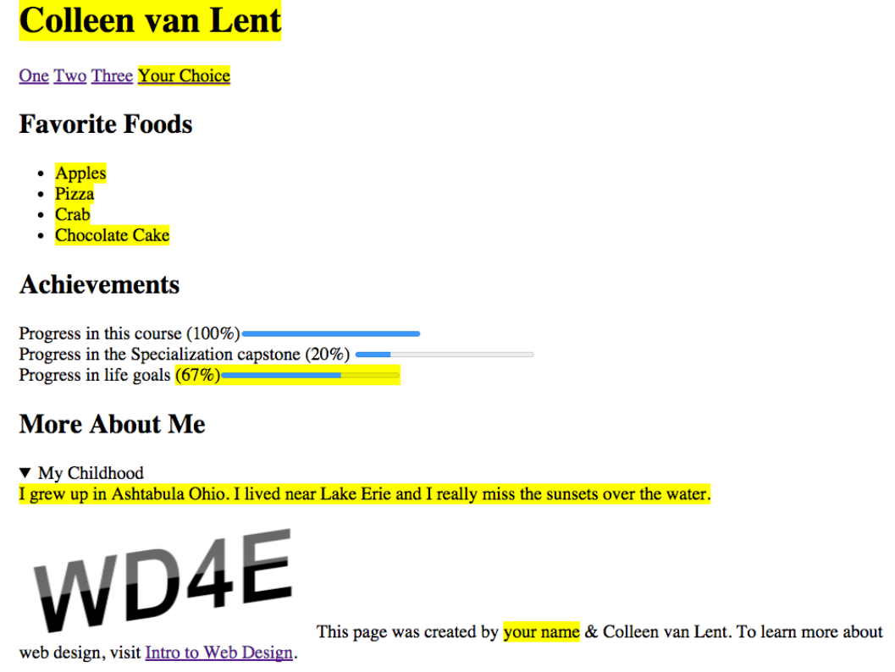

## Grading Checklist

1. **doctype**
2. **head**
3. **body**

* **nav -- add four links, they can go to anywhere you like or nowhere at all**
* **section - Favorite Foods**
* **section - Achievements**
* **section - More About Me**

4**. footer - The image from the footer can be found at my website:** <http://www.intro-webdesign.com/images/newlogo.png>

## Peer Grading

For this assignment you will be grading the submission of your peers and they will be be grading your work as well.

Please note that you must get this COMPLETELY correct to receive credit. You will get frustrated. You will put in silly mistakes. But hang in there. And don't forget to reach out for help if you need it.

Hi.

Let's talk about the final project you're going to do for this course.

The last thing I want you to do is basically take the elements, take the tags,

take the syntax you've been learning about over

these past few weeks and put them together to create an example page.

You'll be provided with a screenshot as a template for what I want you to build,

but it's always easier if someone can tell you in words what goes along with the picture.

When you make this page,

the most important thing I want you to realize is that there are no tricks.

I'm really just testing for syntactic accuracy.

So, let's take a look at the site you're going to be creating.

Here's the site right now.

Depending on what size screen you're looking at,

it can look really different.

So, just for fun, I'm gonna resize my browser just to give people

an idea that I really haven't styled this to do anything particular.

When I make it smaller, things move around.

I don't care where things layout on your screen.

I'm more worried about the fact that each element is there.

I also want to point out that as you can notice,

some of the elements are in yellow and others are just in regular color.

Anything that's in yellow is something that you should change specifically to you.

So, in this case, I have Colleen van Lent in yellow.

You should really use your name instead.

I have a list of my favorite foods.

I really want you to pick your favorite foods.

I've got a little thing along the bottom that says progress and life goals.

Again, pick your own value.

So every place that you see yellow,

I want you to change to your own particular interests, names, values.

Okay. The other thing I want to point out is right down here,

where you see the more about me,

this is actually part of a details tag.

When I click on it,

you can see that it opens and closes.

This is another place where I wanna put more information about you, not about me.

Now, if you were looking at my site on Firefox,

if you're developing in Firefox,

I just want to let you know that this tag doesn't work.

Instead it would always show up as open.

That's fine if that's the type of browser you've been testing on continue to do so.

I just didn't want you to get worried when it didn't seem to

open and close like for everyone else. All right.

So, go ahead.

You're going to make sure that you have a header up here,

a navigation bar here.

This is one section and another section and again the picture may seem big or small.

I don't really care what it looks like.

What I care about is your ability to write HTML 5 code.

So, good luck as you write your code.

I know you're gonna do great,

and it's important to just take small steps and get each one to work individually.

When you're done, you're going to have something that you can be really proud of.

**# Getting Started with your Lab Sandbox**

**## What tools are already installed in this environment?**

- Browser Preview Extension (enables you to preview HTML and CSS within your Lab)

**## How can I find my course files in Visual Studio Code?**

- After opening the lab for the first time or if you have

  not used it for a while, it opens to a blank IDE.

  If this is the case, click on the **\*\*Explore\*\*** icon on the left

  column (the one that looks like two sheets of paper stacked

  together). Then, click on the **\*\*Open Folder\*\*** button.

  In the list that appears, select **\*\*project\*\*** and click **\*\*OK\*\***.

  Your files will be stored in "home/coder/project".

**## How can I preview my HTML code with the browser preview extension?**

1. With your HTML file open in the editor, right click and select

**\*\*Open with Live Server\*\***. There will be a message in the

  lower right corner stating that the server is started at port 5500.

2. Now, go to the icon tool bar on the left side of the screen and

  select **\*\*Browser Preview\*\*** (it should be the last icon

  on the bottom). A mini browser will open, in the address bar,

  type **\*\*localhost:5500/[path to your file]\*\***

  (for example: **\*\*localhost:5500/index.html\*\***), then hit enter.

3. As long as you keep the live server running and the mini

  browser open, you will see your changes reflected in the

  mini broswer in real time.

**### How can I leverage the debugger tool?**

- More information on this can be found here: https://code.visualstudio.com/docs/editor/debugging

**### How can I use the terminal?**

- More information on using the VSCode integrated terminal can be found here: https://code.visualstudio.com/docs/editor/integrated-terminal

**## Additional Course Specific Notes:**

**### Are console logs available to help me troubleshoot my web development work?**

- The embedded VSCode Browser Preview tool does not support viewing of browser

  console logs. However, you can use your standard browser inspect element tool to

  investigate page elements in your web applications.

**### Why am I getting errors in my lab when trying to access other websites?**

- This Lab Sandbox environment does not have

  access to outside websites. Similarly, font-awesome, hyperlinks and

  external image and media links will not work in the lab sandbox.

  To access these sites, please open these links in a new tab in your

  web browser (outside of your lab).

**# Welcome to your Lab Sandbox**

We’re glad you’re here! Let’s get you started in your Lab Sandbox

with a quick README to answer any questions you might have.

It’s preconfigured by Coursera and includes all dependencies

(libraries and packages) to complete your work in Visual Studio Code.

You can practice, run test cases, and work on assignments from your browser.

Learn more about the Coursera Lab Sandbox and how to use the VSCode

sandbox environment (including how to upload and download files)

in the Learner Help Center :

https://learner.coursera.help/hc/articles/360062301971

**## How can I get started?**

1. Read Getting Started with Your Lab for important course-specific guidance.

2. Download any assessment or starter files that were included

   in the course instructions and materials. You can download most files

   by clicking on them. If the file opens in a new browser tab, right click

   on a blank area of the browser page and select Save As to save your file locally.

3. Upload your files into the Lab Sandbox and complete the course work.

4. When you’re done, save your work in your sandbox.

**## How can I receive a score for work completed in the Lab Sandbox?**

1. To receive a score for your work within Coursera, follow the course

   instructions listed within each assignment.

2. If you’re working on a Programming Assignment or Peer Review, you can

   download your Lab files to your local computer and upload them directly to the

   assignment. If you are working on a Quiz, you can use your Lab environment to

   complete your work and then select your responses directly within the quiz.

3. If you have any questions as you get started, we recommend reviewing

   Getting Started with Your Lab for course-specific guidance on how to work

   with the Lab Sandbox for this course.

**## How can I get help with my Lab Sandbox?**

You can learn more about how to use the Lab Sandbox environment

and find tips to troubleshoot in the Learner Help Center.

Coursera currently maintains Lab Sandboxes and course instructors don’t

have the ability to modify or troubleshoot sandbox environments.

If you do run into any time sensitive platform issues, instead of contacting

the course instructor and/or staff, reach out to our 24/7 chat support.

in the Learner Help Center. https://learner.coursera.help/hc

Happy learning!

# **Congratulations!**

Well done on taking the leap and learning more about the way web pages are created and transferred across the Internet. If you enjoyed this course and would like to take a next step you may be wondering where to go. This course is the first course in the Web Design for Everyone Specialization offered by Coursera. The other courses in this specialization include:

### **Introduction to CSS3**

In this course you will take simple HTML documents and use Cascading Style Sheets (CSS) to make them look less like the are from 1992 and more like the beautiful, well-designed sites you see today. All of the major aspects of styling will be covered, while still maintaining our focus on accessibility. In fact, designing with accessibility in mind takes on even greater importance since many people ignore the core principles and tend to use color, images, and font to convey information instead of using semantic tags.

### **Adding Interaction with JavaScript**

Ever notice how some pages react to mouse clicks, screen swipes, or information you type into forms? This is often done using the JavaScript programming language. This course offers you an overview of the techniques and best practices for adding interaction to your site.

## Responsive Design

Responsive design is the ability to design a site with multiple screen sizes (or "platforms") in mind. We have all been to a site that doesn't really work from a mobile device, or other sites that waste space by using small text on a big screen. In this course you will learn to design your site to automatically respond to the platform it is viewed on. Techniques include determining specific screen sizes yourself, or using popular template platforms such as Bootstrap to handle the responsive aspects for you.

### **Web Design for Everyone Capstone**

The capstone is your chance to fail. Again and again. Why would I put it that way? Because you can not really call yourself a web designer until you have had to test and debug your site multiple times. New information will not be covered in this course, instead you will be given weekly checkpoints as you design, code, and debug your own responsive, interactive site. The emphasis on accessibility will remain. Upon completion of the capstone you will have a portfolio-ready site.

Hi everybody.

I'm not sure if I should say welcome back or goodbye.

Because this is the end of the class.

I know that you might be a little bit surprised like, what that's it?

I don't feel like I'm ready to be a web developer yet.

Well I'm here to tell you, your not ready to be a web developer.

But what you have learned is that with the exception of a few things called forms and

a little bit about graphics, you have learned the bulk of the HTML 5 tags.

You've learned their syntax and their semantics.

With that information, you are now ready to go off and

learn even more about the areas that really interest you in particular.

Whether that's design, accessibility, user experience.

And it's very important that you have this basic understanding

before you go into these other ideas.

So let's think about some of the things you've learned.

One of the first tools that's now in your toolbox is that you can view and

edit code, which is something a lot of people have difficulty with.

You can use that editor to modify an existing HTML file.

You can create one from scratch.

There's a lot of different things that you can do using the editors that

you've now mastered.

You also know the different options for opening a file.

I'm not sure if you remember, but just a few short weeks ago when you saw

an HTML file, probably the only thing you could do was open it in a browser.

Now you know how to do many more things than that.

You also are at the very beginning of learning how to evaluate for

accessibility.

From the first step of viewing other people's source code and looking for

those semantic tags, you know the importance that these tags have for

people who want to access your page.

You also have the ability to gothe validator.org to check for

well-structured syntactic code.

Or to go to WebAIM to check for that semantic structure that people may or

may not be using in their code.

Again, the ability to evaluate accessibility is something

that we really need more and more people to know.

Finally, you also, hopefully, know how to publish your site or at the very least,

you know the basics if you do decide to publish in the future.

You know about domain names, you know about hosting, and

you know that you really don't want to buy that one domain name they keep

trying to sell you in the Super Bowl unless you're also willing to buy a host.

You've also achieved some familiarity, no matter how small, with so

many systems that are out there.

You've learned about cPanel, you've learned about FTP, you've learned about

different browsers, and you've learned about different types of editors.

And this is all information you can use to expand your knowledge in other areas.

So what should you do next?

If you've found this course interesting,

what you really want to do is you want to practice you skills.

Keep writing code, keep using tags.

It there is a tag you're not sure about.

That is especially the one that you want to practice with.

You want to get comfortable with multiple editors.

If you've been using Notepad Plus Plus, try Sublime.

If you've been using Sublime try Textwrangler.

Keep working with different editors, and

while you're at it, try different browsers too.

Try uploading your code.

If you didn't host your site, I really encourage you to

find a free hosting service and try putting it out there.

Because once you can share your code with other people

you get much more motivated to do new things.

And finally, the most important thing you probably wanna do,

is learn about cascading style sheets.

Cascading style sheets is a method you're gonna use to take your plain,

everyday HTML file and make it look like something really special.

Of course, I happen to be offering a course in CSS 3,

and I hope you'll join me for that.

But if you decided you just don't have the time to do that, I want to let you know

that when this course is over and after you've submitted your final project,

I will be sending you a link to what I call my secret lecture.

And in that secret lecture,

I want to show you ways that you can style your page in very simple steps.

And I hope it's something you'll enjoy and

help you to continue your journey into HTML 5.

# **Keep Learning with Michigan Online**

Want to keep learning? Explore hundreds of learning experiences from the University of Michigan faculty and instructional teams on [Michigan Online](https://online.umich.edu/?utm_source=coursera&utm_medium=course-resource&utm_campaign=michigan-online-branding).Be the first to know about new learning experiences from the University of Michigan! [Subscribe](https://online.umich.edu/subscribe/?utm_source=coursera&utm_medium=course-resource&utm_campaign=michigan-online-branding&utm_content=email-subscription) to the Michigan Online email list!

# **Watch for a link to more material**

Keep an eye out for an email from me once you complete this course. In the email I will include a link to the "Secret Lecture" I taped for you. In this lecture I break some of my own rules of coding and show you simple (but not best-practice) tips on styling your final project to make it more attractive. So if you haven't finished the final project, how can you possibly procrastinate now that you know there is a secret lecture???